4.4 Assessing Vulnerability: Estimating Potential Losses

This section presents exposure, damage, and loss estimates, for each of the 11 hazards evaluated. The findings support local and regional planners’ understanding of the potential impacts associated with each hazard and provide a foundation for the mitigation strategy presented in Section 5. Where quantifiable loss estimates are feasible, these results are presented. Where quantifiable loss estimates are not feasible using existing data, comparative evaluations of the risks posed by each hazard are presented and demonstrate the types of impacts that can occur, current knowledge of the study area relative to each hazard, and a qualitative vulnerability assessment of each hazard. For these hazards, future efforts will include the development of additional data so that quantitative loss estimates may be feasible in the future; to comply with DMA 2000, a data collection plan addressing current data needs is included in the mitigation strategy section of this plan.

For this portion of the risk assessment, available data, methodologies, and assumptions were used to select and apply a risk assessment methodology for each hazard. Table 4-4-1 shows the risk assessment methodology selected for each hazard.

Table 4-4-1. Summary of Risk Assessment Methodology Selection
Hazard | Comments | Output
HAZUS-MH Methodology
Flood | HAZUS-MH-provided data were used and supplemented with local data for critical facilities. The HAZUS-MH models were used to obtain exposure and loss estimates. | HAZUS-MH Exposure and Loss Estimate Maps, Tables and Text
Hurricane (Part of Severe Storm) |  | HAZUS-MH Exposure and Loss Estimate Maps, Tables and Text
HAZUS-MH Supported Methodology
Severe Winter Storm (Including Ice Storm) | Sufficient historic data were not available to forecast the probability of future hazard events. However, available historic and professional expertise regarding areas at risk for each hazard was compiled from a variety of sources. Professional judgment and available data were then used to evaluate past and potential events, and assess risks in a qualitative manner. HAZUS-MH was used to support inventory evaluations and graphical presentations of areas at risk. | HAZUS-MH Supported Exposure Estimates and Input to Data Needs Portion of Mitigation Strategy (Section 5)
Utility Failure
Severe Storm (Non-Hurricane Portion)
Epidemic (Agricultural)
Transportation Accident (Including Hazmat Release [In Transit])
Water Supply Contamination
Terrorism
Epidemic (Human)
Fire (Urban and Wild)
Civil Unrest

The two methodologies used to assess potential exposure and losses associated with priority hazards of greatest concern to Tompkins County and the seven participating jurisdictions are summarized below:

- HAZUS-MH is a parametric model in that distinct hazard and inventory parameters (for example, wind speed and building types) are considered quantitatively to determine the potential impact (damages and losses) on humans, buildings, roads, and other assets. The HAZUS-MH risk assessment methodology was applied using HAZUS-MH software to estimate losses associated with the flood and hurricane hazards. HAZUS-MH loss estimate data include the three areas summarized below:

- The replacement values for general building stock; this includes the cost of full repair or replacement to the building stock based on damage associated with a hazard event. For buildings, replacement value addresses the aggregate loss and replacement value for structural replacement, non-structural replacement, and content replacement.

- Impact to critical facilities and lifelines, where feasible. For this assessment, the percent of building damage or the range of damage (from none to severe) is evaluated using HAZUS-MH. This also can be used to estimate the annual loss, where value data for critical facilities is available. However, for critical facilities, the functionality of facilities after a hazard event is generally the primary focus.

- Population at risk or impacted. Using the inventory data in HAZUS-MH, population related data are analyzed to assess the potential population that could be impacted by the hazard.

- HAZUS-MH support can assist the evaluation of other hazards, for which built-in models do not yet exist in HAZUS-MH. For example, HAZUS-MH can map hazard areas and calculate exposures if geographic information on the locations of the hazards are available. For most of the hazards evaluated in this risk assessment, historic data are not adequate to model future losses. However, for some hazards, areas of concern could be identified. For other hazards, such as the winter storm hazard, the entire study area is at risk, or exposed, to the hazard. For these hazards, available data, professional knowledge, and evaluation of local data are used to evaluate the qualitative risk, exposure and loss associated with each hazard. This evaluation provides a sound basis for, mitigation strategies developed in Section 5. This approach was applied to nine hazards of concern, including the following:

1) Severe winter storm (including ice storm)
2) Utility failure
3) Epidemic (agricultural)
4) Major transportation accident (including Hazmat release [in transit])
5) Water supply contamination
6) Terrorism
7) Epidemic (human)
8) Fire (urban and wild)
9) Civil unrest

For the HAZUS-MH supported analysis, data from HAZUS-MH augmented with local data was used to assess vulnerabilities of inventory and affected populations at risk based on the designated hazard areas identified in Section 4.2 of this plan for each hazard. The percent of inventory vulnerable to each hazard was evaluated based on historic information and best professional judgment using the best readily-available data. With time, additional data collection and research will support further refinement of the exposure and loss estimate results.

When feasible, matrices of inventory by building type and critical facilities grouped by municipality were developed to identify the exposure values in each hazard area. In some cases, based on the nature of the hazard, values for the study area are presented as “at risk”. In these cases, assumptions are made about percentages of property or population that could be impacted to assess exposure.

All of the exposure assessments and loss estimations are based on the best readily available data. Where information limitations exist and prevent completion of this section to fulfill DMA 2000 requirements, the following are described under Data Needs:

(1) An explanation of why the assessment could not be completed;
(2) A summary of additional data needs for further analysis; and
(3) Measures that will be undertaken to gather data to complete the analysis over time.

Additional data that would be useful to estimate losses or exposure for the hazards of concern are also summarized in Table 4-4-22 at the end of this section. This data supplementation effort is included as a mitigation action in the mitigation strategy portion of this plan. The planning group adopted this methodology based on FEMA’s How To Guide, which states “in cases where loss estimation tables are not currently available, base your assumptions on your past experience with those hazards in your planning area”. Also, DMA regulations state that the best available data is acceptable and plans to supplement data over time should be addressed. Therefore, when the extent of damage cannot be identified, the vulnerable asset data values and qualitative assessment of risk suffice for this mitigation plan. Future updates to this plan will improve and refine the analyses presented in this plan.

As discussed in Section 4.1, hazards are presented by category in the following order:

Natural Hazards

1) Flood
2) Severe winter storm (including ice storm)
3) Severe storm (including hurricane)
4) Epidemic (agricultural)
5) Epidemic (human)
6) Fire (urban and wild)

Technological Hazards

1) Utility failure

Human-Caused Hazards

1) Transportation accident (including Hazmat release in transit)
2) Water supply contamination
3) Terrorism
4) Civil unrest

Major data sources used to derive the inventory exposure and loss estimates presented in this section are included in Appendix C and listed in the references section of this document.

Natural Hazards

Natural hazards are summarized in this section flood, severe winter storm (including ice storm), severe storm (including hurricane), epidemic (agricultural), epidemic (human), and fire (urban and wild).

4.4.1.1 Flood
A flood polygon is a GIS vector file outlining the area exposed to the flood hazard. HAZUS-MH generates this polygon at the end of the flood computations in order to analyze the at-risk inventory.
A GIS shape file is a type of GIS vector file that was developed by ESRI for its ArcView software. This type of file contains a table and a graphic. The records in the table are linked to corresponding objects in the graphic.
Flood is a significant concern for the study area. The flood hazard exposure and loss estimate analysis is presented below.
Data Collected and Used
Input data collected and reviewed for the flood hazard includes local damage data from historical flood events and FEMA Q3 flood polygon data, which delineate the 100- and 500-year flood plain boundaries. Population data were taken from HAZUS-MH and are based on the most recent census conducted in 2000 (FEMA 2004). General building stock data was used as provided in HAZUS-MH, supplemented by local data regarding critical facilities and lifelines.
The modeling approach used Q3 flood zone flood polygon data and U.S. Geologic Survey (USGS) Digital Elevation Model (DEM) data to estimate the base elevation. Given the size of the area of interest, a third-party tool, the HAZUS-MH flood macro was used to support analysis of the entire study area.

The HAZUS-MH methodology was customized to analyze the flood hazard for Tompkins County. Losses were estimated for a 100- and a 500-year mean return period (MRP) flood event. The 11 residential and 10 commercial occupancy classes available in HAZUS-MH were condensed into three occupancy classes (residential, commercial, and industrial) to facilitate the analysis and the presentation of results. Residential loss estimates address both multi-family and single family dwellings.

In addition, impacts to critical facilities were evaluated for the 100-year and 500-year MRP flood events.

Exposure and Loss Estimation

Table 4-4-2 shows the potential population estimated to be at risk for the 100- and 500-year MRP flood events. The 100-year flood event is a flood with a magnitude that has a 0.1 percent probability of occurring in any one year.

Table 4-4-2. Estimated General Population at Risk from Riverine Flood by Jurisdiction
Jurisdiction | 100-year Flood | 500-year Flood
Jurisdiction | Population Within Flood Zone | Population Within Flood Zone
Caroline | 130 | 130
Danby | 30 | 30
Enfield | 0 | 0
Groton | 103 | 136
Ithaca | 210 | 230
Lansing | 160 | 160
Ulysses | 180 | 180
Total | 813 | 866
Notes: The population represents the population that lives in the flood plain area. A large portion of the flood plain area is located in the City of Ithaca, which is not included in this plan.

Based on the flood zone evaluation, about 2 percent of the population of the study area is living in areas that are at direct risk for the flood hazard. In addition, about 7,912 people live in census blocks that intersect the flood zone (within or bordering a flood plain). These persons are not expected to suffer direct losses but could be impacted by floods if they exceed the 500-year MRP event and could suffer indirect impacts through road closures, and stresses placed on emergency services.

Figure 4-4-1 shows the extent of the 500-year flood zone in relation to the population density to illustrate areas of the city where populations would be most impacted. Figures 4-4-2 and 4-4-3 show the population densities for elderly and low-income populations in relation to the 500-year flood zone, respectively.

Figure 4-4-1. Distribution of Population Density Relative to 500-Year Flood Extent for Tompkins County Study Area
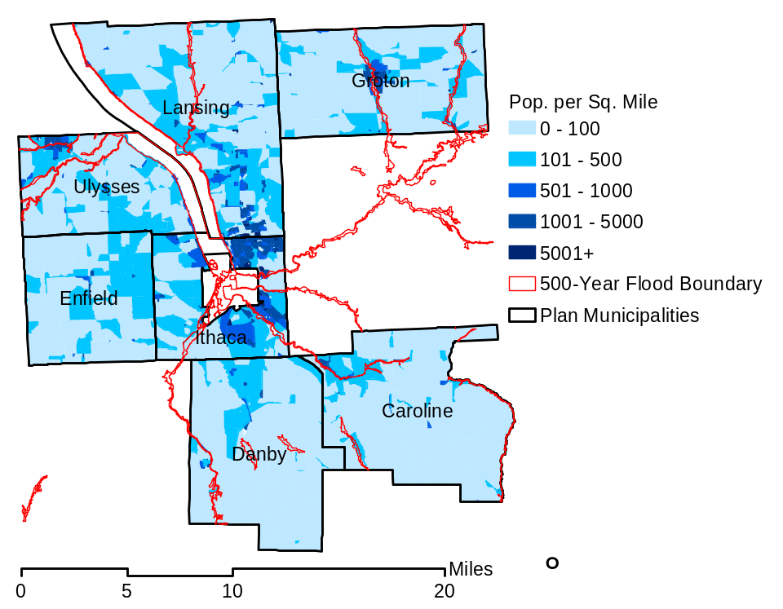
Figure 4-4-2. Distribution of Elderly Population Density in Relation to 500-Year Flood Extent for Tompkins County Multi-Jurisdictional Study Area
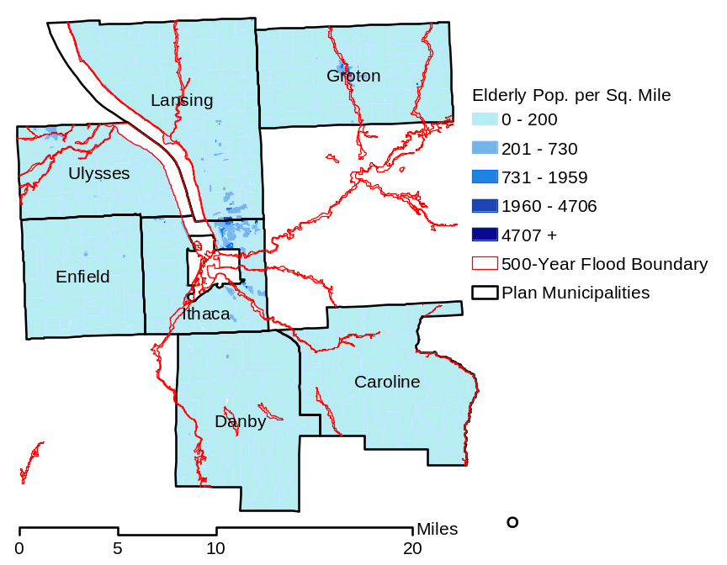
Source: HAZUS-MH (FEMA 2004)

Figure 4-4-3. Distribution of Low-Income Population Density to 500-Year Flood Extent for Tompkins County Multi-Jurisdictional Study Area
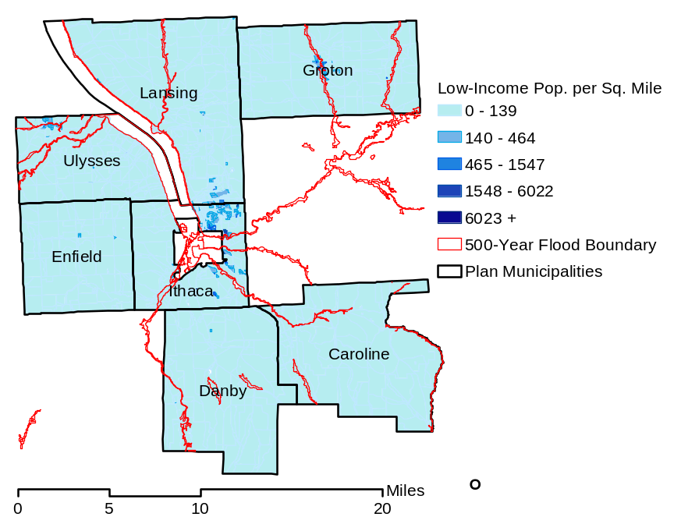
Source: HAZUS-MH (FEMA 2004)

The total exposure value for buildings in the flood zone considered “at risk” is summarized in Table 4-4-3 for both the 100-year and 500-year MRP flood events.

Table 4-4-3. Estimated Exposure Values for General Building Stock for Tompkins County Study Area
Category | 100-year Flood |  | 500-year Flood
Category | Building Count | Dollar Value | Building Count | Dollar Value
Residential Exposure (Single and Multi-Family Dwellings) | 396 | $89.9M | 422 | $99.9M
Commercial Exposure At-Risk | 3 | $6.8M | 4 | $11.2M
Industrial Exposure At-Risk | 0 | NA | 0 | $0.6M
Educational (Universities) | 0 | NA | 0 | NA
TOTAL AT-RISK | 399 | $96.7M | 426 | $111.7M
Notes: M - Million. Dollars rounded to the hundred thousand. Estimate includes building and building content exposure.

For this project, the potential population impacted is used as a guide to consider the potential maximum number of persons that may be displaced or require shelter during a flood. The total number of injuries and casualties resulting from flooding is generally limited based on advance weather forecasting, blockades and warnings. Therefore, injuries and deaths generally are not anticipated should this hazard occur. Ongoing mitigation efforts should help to avoid the most likely cause of injury, which would be from those trying to cross flooded roadways or channels during a flood.

Table 4-4-4 estimates property damage due to the flood hazard as a function of building structure content, and total loss. The damage value includes an aggregate value for buildings damaged at all severity levels, from slight damage to total destruction; the total dollar damage estimates the impact to individual buildings at an aggregate level. For the flood hazard, the content of buildings is a primary loss item, as reflected in the table below.

Table 4-4-4. Estimated Damages to General Building Stock from Floods for Tompkins County Study Area
Occupancy Class | 100-year Flood |  |  | 500-year Flood
Occupancy Class | Structure Damage | Content Loss | Total Loss | Structure Damage | Content Loss | Total Loss
Residential | $1.1M | $2.1M | $3.2M | $1.4M | $2.5M | $3.9M
Commercial | 0.36M | 0.33M | $0.69M | 0.36M | 0.33M | $0.69M
Industrial | $0M | $0M | $0M | $0M | $0M | $0M
Educational | $0M | $0M | $0 | $0M | $0M | $0
Total | $1.46M | $2.43 | $3.89M | $1.76M | $2.83M | $4.59M
Notes: M - million. Educational above indicates university facilities; schools for kindergarten through high school are evaluated with critical facilities.

Because several communities rely heavily on agriculture, agriculture exposure and risk also was evaluated. Figure 4-4-4 shows agricultural areas in the study area.

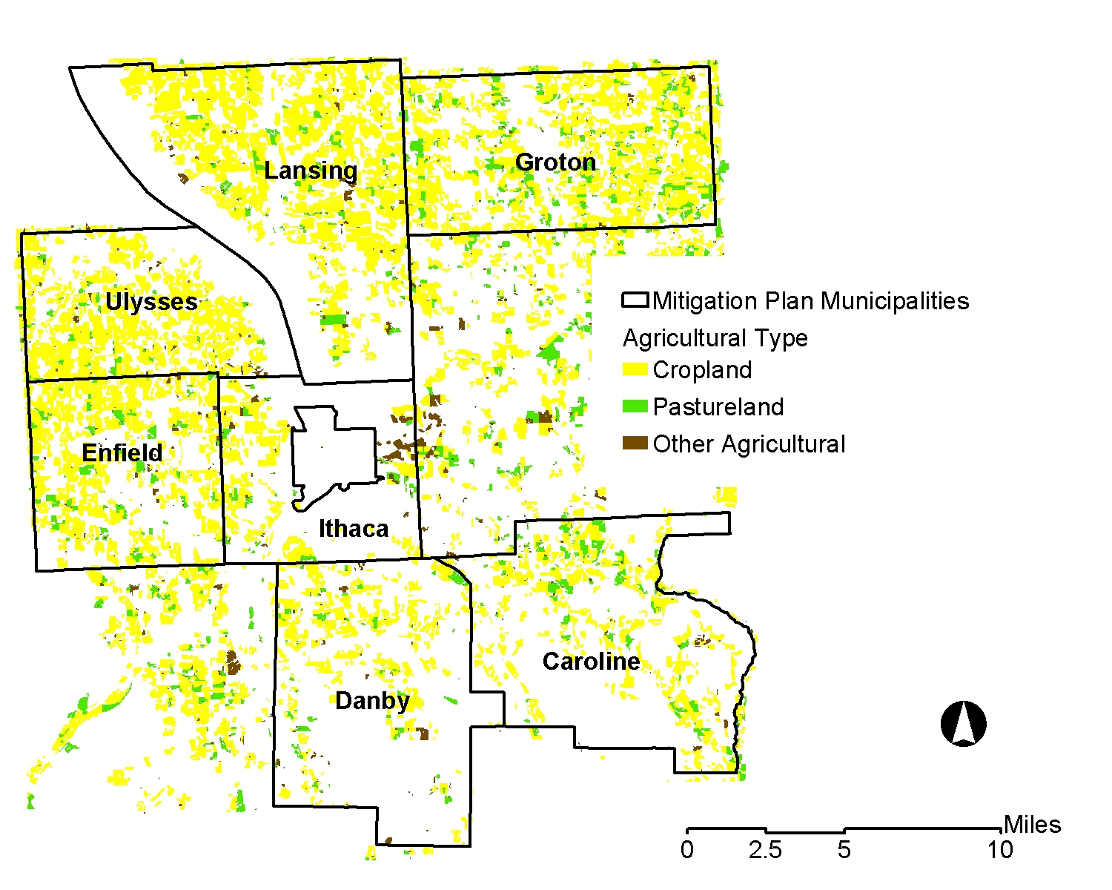
Figure 4-4-4. Agricultural Lands in Study Area

Agricultural areas within the 100- and 500-year flood zones could also be adversely impacted by flooding. Table 4-4-5 indicates the agricultural risk within the 100-year flood plain. Because the 100-year and 500-year flood zones are similar in areas where crop land and agriculture are located, the exposure for the 500-year MRP flood event for agriculture is similar to the 100-year MRP flood event exposure.
Table 4-4-4a. Estimated Exposure Values for Agricultural Lands for Tompkins County Study Area
Category | Total Acreage in Study Area | Acreage in 100-Year Flood Plain | Percent of Total
Cropland | 65,008 | 202.7 | 0.3%
Pastureland | 7,228 | 94.4 | 1.3%
Other Agriculture | 1,950 | 10.1 | 0.5%
TOTAL AT-RISK | 74,186 | 307.2 | 0.4%
Notes: N/A indicates not applicable

Areas where this agricultural exposure is concentrated include the Towns of Ulysses. For the flood estimate, exposure of major agricultural buildings and facilities also was evaluated. One such facility was estimated to be exposed and suffer losses in the study area. This facility is located in Ulysses and the exposure loss data for this facility are presented in Table 4-4-5.

Table 4-4-5. Estimated Agricultural Exposure and Loss for Floods for Tompkins County Study Area
Occupancy Class | Facility Exposure | 100-year Flood | 500-year Flood
Occupancy Class | 100- and 500-Year Flood | Damage | Damage
Ulysses (one agricultural facility (building) at risk) | $398,000 | $17,800 | $17,800
Notes: The one facility at risk lies within both the 100- and 500-year flood zone and therefore, exposure and losses are equivalent for both flood events.

Upon evaluation of wastewater treatment facilities, transportation lifelines, and other infrastructure, it was determined that no major flood risks exist for the 100- and 500-year flood based on precautions already in place and the nature of infrastructure in the area, which is fairly resistant to the flood hazard. Only one critical facility, the Groton Community Health Care Center is exposed to the flood hazard based on evaluation of the location of critical facilities and the 100- and 500- year MRP flood plain zones. One Hazmat facility lies in the flood zone, towards the north of the study area in the northern portion of the study area. Therefore, it appears that the risk to critical infrastructure and Hazmat sites is not extensive for the flood hazard.

Additional Data Needs and Next Steps

Over time, the jurisdictions in the plan and other jurisdictions in the Tompkins County area will continue to work together to learn more about the flood hazard, maintain or improve participation in FEMA’s National Flood Insurance Program (NFIP), and support further mitigation efforts, as discussed in Section 5 to reduce the losses should future flood events occur. Refinement of floodplain maps and improvement of local inventory data will support refined analyses using the flood model over time. Future evaluations may apply the HAZUS-MH model to study particular reaches of concern in greater detail. Also, the model may be used to estimate the impact of particular mitigation activities that could be implemented to reduce flood risk. Also, as new or refined flood maps are created and development and mitigation efforts occur, future evaluations will consider any changes to the flood loss estimates presented in this plan.

Overall Vulnerability Assessment

The flood hazard is evaluated as a significant threat, which can be managed and planned for through the mitigation strategy and specific activities outlined in Section 5.

4.4.1.2 Severe Winter Storm (Including Ice Storm)

Severe winter storms and ice storms are of significant concern to Tompkins County and the municipalities due to the frequency and magnitude of these events in the region, the direct and indirect costs, delays, and impacts on the people and facilities of the region related to snow and ice removal, health problems, cascade effects such as utility failure, flooding from ice jams, and stress on community resources.
Data Collected and Used
National weather databases, Tompkins County, and jurisdictional data were collected, analyzed, and sorted. Severe winter storm events were categorized and grouped by type of event: heavy snow, severe winter storm, and ice storm. Based on categorization, available information regarding the frequency and duration of occurrences of each severe winter storm event type was collected and analyzed. Data on property damage and loss, and injuries and deaths, was collected for Tompkins County from NOAA’s NCDC website. This data was used to support an evaluation of exposures to this hazard.
Exposure and Loss Estimation

While the HAZNY evaluation resulted in severe winter storm being ranked as the 10th highest hazard of concern (of 13) and ice storm being ranked as the 5th highest hazard, the severe winter storm was elevated to the second most significant hazard to the study region based on the experience and judgment of the residents and planning group and the combination of the two hazards for further evaluation as part of this mitigation plan.

Heavy snowfall, coupled with low temperatures, often results in increases in traffic accidents; disruptions in transportation, commerce, government, and education; utility outages due to falling trees, branches, and other objects; personal injuries associated with slippery surfaces and freezing temperatures; and numerous other problems. Specific damages associated with severe snowstorms and ice storms in the study area include the following primary concerns:

- Injuries, including fatalities, associated with accidents, low temperatures, power loss, and falling objects caused by frozen and slippery surfaces
- Increases in the frequency and impact of traffic accidents, which result in personal injuries
- Ice-related damage to trees, building and infrastructure inventory, and utilities (power lines, bridges, substations, etc.)
- Ice jams that cause traffic problems on waterways and flooding
- Roads damaged through freeze and thaw processes
- Stress on the local shelters and emergency response infrastructure
- Lost productivity that occurs when people cannot go to work, school, or stores due to inclement conditions

Some minimum damage is anticipated annually, with extensive damage occurring once every 10 years. Fortunately, Tompkins County is relatively well-prepared for severe winter storms, having sophisticated response, early warning, and snow removal systems in place.

The climate of Tompkins County is such that no areas are immune to the potential damaging effects of severe winter storms and ice storms. Data is only available to support evaluation of ice storm events since 1993. Also, limited damage data is available. The assessment of risks associated with ice storms requires correlation with inventory data to determine facilities and resources at particular risk of damage from ice storms, including above-ground infrastructures, such as overhead electric and telephone lines, electrical substations, and bridges.

Spatial information on utilities and other vulnerable inventory is available from Tompkins County, including the location of above-ground utilities. It may be possible to analyze areas at high vulnerability from damages due to falling trees, branches, or other objects onto inventory if information on tree cover (especially vegetation type and maturity level) is available; however, such data were not available in a time frame for this mitigation plan. In the future, the Tompkins County Public Works Department and Building Department, parallel town agencies, and private utilities may make available information on repairs or other maintenance to infrastructure or other inventory associated with snow and ice storms. In addition, tree coverage will be assessed in relation to at-risk structures. Similarly, jurisdictional health or safety departments in Tompkins County and the towns may maintain records that can be reviewed to determine the frequency and severity of injuries or fatalities associated with ice-related accidents, as well as the locations where accidents occur.

Because the NCDC presents event information separately for severe winter storms and snow storms, and ice storms, the known cost/loss information associated with these two categories of winter storms are presented separately in the following paragraphs.

Severe Winter Storm and Snow Storm - Historic data for severe winter storm and heavy snow events between 1993 and 2003 were reviewed to qualitatively identify patterns and information regarding costs. Based on the available data, it is reasonable to assume that at least one severe winter storm and heavy snow event is likely to occur each year in Tompkins County. The entire area of Tompkins County is vulnerable to this hazard. The range of monetary costs associated with severe winter storm and heavy snow events since 1993 is $0 to $6.0 million. As many as 10 injuries and 3 deaths have been attributed to individual storms during this period, the exact cause of which were not determined.

According to Mr. Bud Shattuck, the Deputy Town Supervisor for the Town of Lansing, a traffic accident caused by a winter storm resulted in two state highways being blocked for 4 hours and required truck traffic to be re-routed through the streets of Lansing. The truck traffic on the city streets, coupled with salt and sand applied to the roads reported caused nearly $250,000 in damage to the town’s streets, as well as delays in police and ambulance service.

Ice Storm - Historic information is sufficient from the NCDC to perform rather crude statistical modeling of the frequency of ice storms in Tompkins County. Data on ice storm events is only readily available from NCDC for the years since 1993. Only a few ice storms of note have occurred during that period and reported damages range from $0 to more than $1 million. Based on this limited data, the statistical power of a test to predict storm occurrence and associated losses would be low. In addition, data acquired to this point is insufficient to predict the vulnerable areas and future losses at this time. Based on the available data, it is reasonable to assume that several ice storm events of varying severity will occur within each 10-year period in Tompkins County. The entire area of Tompkins County is vulnerable to this hazard. The range of monetary costs associated with ice storm events since 1993 is $0 to $1.1 million. No injuries or fatalities attributable to ice storm events have been reported during this period. However, it is reasonable to assume that injuries and, in some instances, deaths, could result from ice storm events.

Combined Vulnerability - Populations considered to be most vulnerable to severe winter storm are identified based on a number of factors including their physical and financial ability to react or respond during a hazard and the location and construction quality of their housing. Table 4-4-6 summarizes the population over the age of 65 and living in households with an income below $20,000 per year. Figures 4-4-5 and 4-4-6 show the distribution of these populations.

Table 4-4-6. Population in Study Area Exposed to Severe Winter Storm
Town | Population over age 65 | Population with income less than $20k/yr. | Total Population in Study Area
Caroline | 240 | 215 | 2,910
Danby | 321 | 179 | 3,007
Enfield | 337 | 274 | 3,369
Groton | 691 | 398 | 5,794
Ithaca | 2,064 | 1,510 | 18,710
Lansing | 1,191 | 582 | 10,521
Ulysses | 700 | 386 | 4,775
Study Area | 5,544 | 3,544 | 49,086

Figure 4-4-5. Distribution of Elderly Population for Study Area
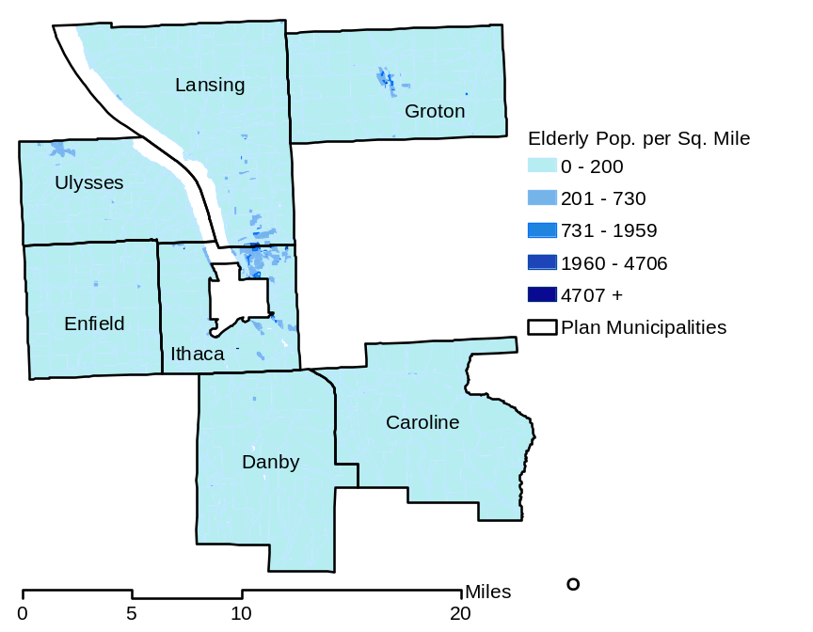

Source: HAZUS-MH (FEMA 2004)

Figure 4-4-6. Distribution of Populations with Income Less Than $20K/year for Tompkins County Multi-Jurisdictional Study Area
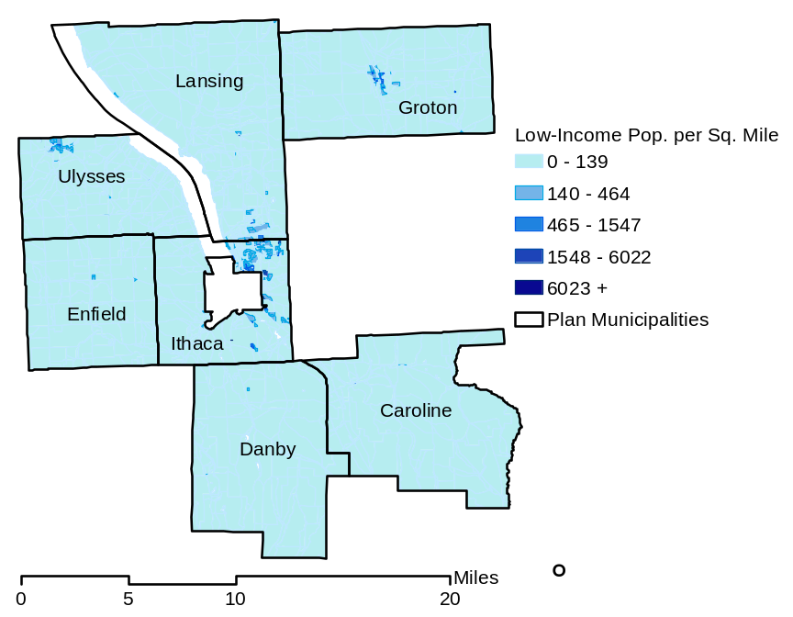
Source: HAZUS-MH (FEMA 2004)

The entire inventory in the Tompkins County Multi-Jurisdictional Study area is vulnerable to a severe winter storm. Table 4-4-7 identifies the building count and valuation of this inventory as well as the losses that would result from 1, 5, and 10 percent damage to this inventory as a result of a severe winter storm.
Table 4-4-7. Inventory of General Building Stock Exposure for Tompkins County Multi-Jurisdictional Study Area
Building Occupancy Class | Number of Buildings | Total Value | 1% Damage Loss Estimate | 5% Damage Loss Estimate | 10% Damage Loss Estimate
Residential | 13,533 | $2.34 billion | $23.4 million | $117 million | $234 million
Commercial | 81 | $0.20 billion | $2 million | $10 million | $20 million
Industrial | 3 | $0.03 billion | $.3 million | $ 1.5 million | $3 million
Total | 13,617 | $2.57 billion | $25.7 million | $129.5 million | $257 million
Note: The building values shown do not include building contents; for the severe storm hazard, damage will generally impact structures such as the frame and major piping.

Historic data indicates losses of approximately up to $6 million dollars per year have occurred in the past; this equals 0.2 percent of the total value of residential, commercial, and industrial buildings and less than a 1 percent damage loss to infrastructure. Therefore, the loss estimates of 1, 5 and 10 percent can be considered conservative estimates of anticipated future damage. An assessment on damage to critical infrastructure cannot be made due to the lack of readily available data on the valuation of this infrastructure. However, historical data such as the damage and repair to roadways is discussed above, as available.

Manufactured homes are particularly vulnerable to severe winter storms. Figure 4-4-7 shows the distribution of these types of homes in the Tompkins County Multi-Jurisdictional Study Area and Table 4-4-8 summarizes this data and estimates the loss if 5 and 10 percent damage accrues to these homes.

Figure 4-4-7. Manufactured Homes in Study Area
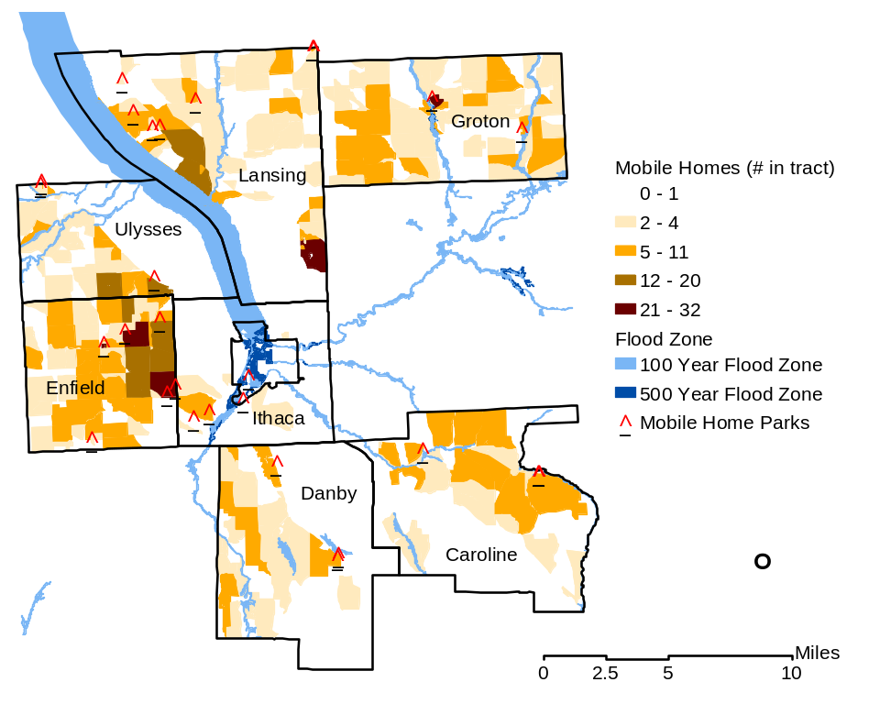
Source: HAZUS-MH (FEMA, 2004); John Anderson (TCDOH, 2004)
Note: The farthest south park icon actually indicates two parks. Additional parks in the north and east also have one icon representing more than one park (due to the scale of this figure). The parks in Ithaca are indicated as "College View Trailer Park", "College View North Trailer Park", and "Shady Farm Trailer Park".

Table 4-4-8. Manufactured Homes in Tompkins County Multi-Jurisdictional Study Area
Town | Total Residential Structures | Total # Manufactured Homes | % of Total Residential Structures | Total Value Manufactured Homes | 5% Damage Loss Estimate | 10% Damage Loss Estimate
Caroline | 998 | 172 | 17% | $5,821,000 | $290,550 | $582,100
Danby | 977 | 123 | 13% | $4,282,000 | $214,100 | $428,200
Enfield | 1,160 | 473 | 41% | $15,633,000 | $781,650 | $1,563,300
Groton | 1,781 | 399 | 22% | $13,580,000 | $679,000 | $1,358,000
Ithaca | 3,813 | 44 | 1% | $1,790,000 | $90,000 | $179,000
Lansing | 3,125 | 362 | 12% | $12,319,000 | $615,950 | $1,231,900
Ulysses | 1,679 | 205 | 12% | $7,282,000 | $364,100 | $728,200
Study Area | 13,533 | 1,778 | 13% | $60,707,000 | $3,035,350 | $6,070,700
Note: The building values shown do not include building contents. Generally for the winter storm hazard, the structural components of buildings are anticipated to be most impacted. Source: HAZUS-MH (FEMA 2004)

Another area that is vulnerable to a severe winter storm is the 100-year flood plain. At risk residential infrastructure are summarized in Section 4.4.1.1. Generally, losses resulting from flooding associated with severe winter storms should be less than that associated with a 100-year flood. However, some flooding could be associated with ice jams. Infrastructure at risk would include roadways that could be damaged due to the application of salt and intermittent freezing and warming conditions that can damage roads over time.
Additional Data and Next Steps

Although event data is available for a period of 10 years, location-specific data regarding damage has not been tracked and correlation to specific infrastructure and inventory areas is not possible because winter storms can impact any portion of the study area. Based on currently available data, modeling of future losses would only be possible for total losses and would have a large margin of uncertainty given the currently available data. However, the exposure assessment discussed above identifies vulnerable populations and infrastructure of particular concern for this hazard. Conservative estimates of potential losses based on “percent of damage” assumptions also are provided in the tables in this section as a guide for planning mitigation options.

As additional valuation data for critical infrastructure and area of impact is obtained, the data in HAZUS-MH can be modified to include the valuation data. This would support estimates of potential exposure and damage for critical facilities.

Additional data could include the collection of cost data from federal and state agencies on the valuation of roadways, bridges and other critical infrastructure. Standard valuation data is available from a variety of public and private sources. For example, if the average cost of a roadway mile, railway segments, and categories of schools, nursing homes, or potable water treatment piping were identified, the assets value could be calculated based on this information. Resources for obtaining this information include but are not limited to the Federal Highway Administration, RS Means, DOT, GSA, and NYSDEC. Also, the study area representatives will track more specific event and loss data to support the identification of particular assets of concern.

Because historic data on losses will not be adequate to predict specific losses to inventory, the percent of damage assumption methodology employed for general buildings and mobile homes in this section can be applied to infrastructure and critical facilities, when valuation data is available. This methodology is based on FEMA’s How To Series (FEMA 386-2), Understanding Your Risks, Identifying and Estimating Losses (FEMA 2001) and FEMA’s Using HAZUS-MH for Risk Assessment (FEMA 433) (FEMA 2004).

Overall Vulnerability Assessment

Severe winter storms, including ice storms, are common in the study area, often causing significant impacts and losses to Tompkins County and the municipalities’ roads, structures, facilities, utilities, and population. Existing and future mitigation efforts should continue to be developed and employed that will enable the study area to be prepared for these events when they occur. The cascade effects of severe winter storms include utility losses and transportation accidents. Losses associated with these hazards are discussed later in this section. Particular areas of vulnerability include low-income and elderly populations, trailer homes, and infrastructure such as roadways and utilities that can be damaged by such storms.

4.4.1.3 Severe Storm (Including Hurricane)

Severe storms, including windstorms, thunderstorms, hailstorms, and tornadoes, can result in power outages, disruptions to transportation corridors and equipment, loss of workplace access, significant property damage, injuries and loss of life, and the need to shelter and care for individuals impacted by the events. A large amount of damage can be inflicted by trees, branches, and other objects that fall onto power lines, buildings, roads, vehicles, and, in some cases, people.
Data Collected and Used
Data used to assess this hazard include data available for hurricanes in HAZUS-MH, NCDC data, professional knowledge and other information provided by participating towns, the American Red Cross, and available from FEMA.

According to NOAA’s NCDC database, no hurricane or tropical storm events have been recorded in Tompkins County since 1950. However, high winds and flooding associated with hurricanes and tropical storms that directly impact other areas have impacted Tompkins County. HAZUS-MH contains data on historic hurricane events. It also includes surface roughness and vegetation (tree coverage) maps for the area. Local vegetative cover maps were obtained from the Tompkins County GIS Department and the New York Department of Environmental Conservation, but were incomplete (only partial coverage of the area). Surface roughness and vegetation data support the modeling of wind force. Hurricane and inventory data available in HAZUS-MH is sufficient to evaluate potential loss from the hurricane hazard (severe wind storm). Locally available inventory and surface cover data were reviewed to determine their appropriateness to support the evaluation of the hurricane hazard. Local data for critical facilities was used to supplement the data provided with HAZUS-MH.

For this hazard, a loss estimate was conducted for the severe storm using the hurricane module of HAZUS-MH. This is appropriate because full-force hurricanes are not likely to occur in Tompkins County due to the distance of the county from the Atlantic Ocean, as well as latitude. However, Tompkins County is capable of experiencing hurricane-force winds at times. For example, a high wind event in 1935 killed an estimated eight to 10 people. Winds associated with Hurricane Hazel (October 1954) and extreme wind gusts affected Tompkins County during the 1970s. More recently, although not technically of hurricane force, local winds associated with Hurricane Isabel reached 40 to 50 mph; this is equivalent to winds indicated by HAZUS-MH for a 100-year MRP event. The entire inventory is considered at risk of being damaged or lost due to impacts of severe wind. However, certain areas, infrastructure, and types of buildings are at greater risk than others due to proximity to falling hazards, structural considerations, ground cover, and vulnerability to wind damage.

Exposure and Loss Estimation

Due to Tompkins County’s inland location, the loss associated with hurricane is primarily associated with hurricane-related rains (see flooding discussion). Wind associated with the hurricane event is more similar to a severe wind storm and therefore, can support analysis of the severe storm event for this area. The damage from hurricane-related winds is considered representative of a severe windstorm due to downed trees and damaged buildings. The HAZNY analysis of Tompkins County estimated that the most damage would likely occur in the Towns of Lansing and Ulysses because of their topography and geography.

Secondary flooding associated with the torrential downpours during hurricanes is also a concern in Tompkins County. Tompkins County has experienced flooding in association with several hurricanes and tropical storms in the past. The flood hazard is described previously in this section.

Limited tornado damage information is available, but indicates that the study area can suffer damage resulting from tornados. For example, the NCDC indicated that over $750,000 in property losses resulted from tornados in Tompkins County during the period from 1950 to 2003. Also, a high wind event in January 2000 caused about $1.1 million in damages over a multiple county area. High winds associated with Hurricane Isabel in September 2003 caused an estimated $850,000 in damages and caused power outages for thousands over a multi-county area, including Tompkins County. Thunderstorm wind events frequently are associated with $10,000 to $20,000 in property damages for each event. Thunderstorm wind events in Groton in June 2002 and August 2003 resulted in $150,000 and $400,000 in property damage, respectively (NOAA NCDC 2004). While not specific to severe storm along (for example, flooding is included), Table 4-4-9 identifies storms that were resulted in Presidential Disaster Declarations in the vicinity of, or for, the study area.

Table 4-4-9. Presidential Disaster Declarations for Severe Storm Events
Type of Event | Date | Declaration Number | Losses (approximate)
Snow | March 1993 | DR 3107 | $113,939
Flooding | January 1996 | DR 1095 | $251,898
Flooding | November 1998 | DR 1148 | $225,152
Flooding | June through July 1998 | DR 1233 | $56,591
Severe storms and flooding | May through August 2000 | DR 1335 | $61,521
Severe storm | Summer 2002 | DR 1391 | $5,660
Total Cost | N/A | N/A | $714,761
Notes: Recorded losses indicate the dollar value of loss made available through public records reviewed for this risk assessment. N/A indicates not applicable. Source: FEMA website (http://www.fema.gov/library/drcys.shtm)

In addition to available historic data, the HAZUS-MH methodology and model were used to analyze the hurricane hazard for Tompkins County. Figures 4-4-8 and 4-4-9 show the wind gust speeds that can be anticipated in this area associated with the 100-year and 500-year MRP hurricane events. The figures show the following wind speed ranges:

- 100-year MRP hurricane event: 43 to 47.3 mph
- 500-year MRP hurricane event: 70 to 72.8 mph

Figure 4-4-8. Wind Gust Speeds for 100-year Hurricane Event
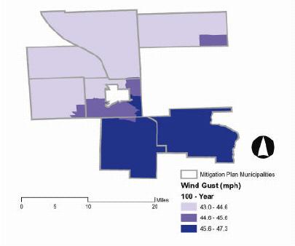
Figure 4-4-9. Wind Gust Speeds for 500-year Hurricane Event
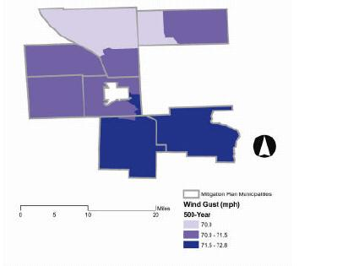
Table 4-4-10 summarizes the property damage that is estimated for the 500-year MRP hurricane event. Losses associated with the 100-year event are not significant and therefore, are not presented. The data shown indicates losses associated with wind damage to structures. Residential buildings account for most of the total loss for this event. Because of differences in building construction, residential structures are generally more susceptible to wind damage than commercial and industrial structures. The damage counts include buildings damaged at all severity levels from slight damage to total destruction. Total dollar damage estimates are the overall impact to individual buildings at an aggregated level.

Table 4-4-10. Estimated Damages/Losses to General Building Stock from Hurricane in Tompkins County Multi-Jurisdictional Study Area
Town | 500-year MRP Hurricane Event
Town | Residential Damages |  |  | Commercial Damages |  |  | Industrial Damages
Town | Structure | Content | Total | Structure | Content | Total | Structure | Content |  | Total
Caroline | $107,200 | $42,000 | $149,200 | $139 | $0 | $139 | $54 | NE | $54
Danby | $117,900 | $45,900 | $163,800 | $484 | $0 | $484 | $53 | NE | $53
Enfield | $171,900 | $6,900 | $178,800 | $754 | $4 | $758 | $309 | NE | $310
Groton | $221,500 | $1,200 | $227,700 | $1,720 | $4 | $1,724 | $217 | NE | $217
Ithaca | $678,900 | $54,400 | $733,300 | $6,544 | $18 | $6,562 | $977 | NE | $977
Lansing | $586,500 | $25,500 | $612,000 | $8,708 | $32 | $8,740 | $861 | NE | $861
Ulysses | $338,500 | $6,500 | $395,000 | $4,548 | $41 | $4,589 | $453 | NE | $454
Total for Study Area | $2,222,400 | $182,400 | $2,459,800 | $22,897 | $99 | $22,996 | $2,924 | NE | $2,926
Note: NE indicates negligible loss.

The percent probability of experiencing damage of various severities is summarized for the 500-year event in Table 4-4-11. The hurricane analysis considers damage associated with significant winds, which could occur as a result of the hurricane, severe wind storms, or tornadoes. Rain often is associated with hurricanes and heavy rains could result in flooding. Flooding is addressed under the flood hazard.

Table 4-4-11. Estimated Percent Probability of Various Damage Levels Associated with Hurricane Severe Storm Event
Category | 500-year MRP Hurricane Event
Category | Percent Probability of Experiencing Damage | Severity of Damage Experienced
Residential Exposure (Single and Multi-Family Dwellings) | 0 to 2% | Minor
Residential Exposure (Single and Multi-Family Dwellings) | 0 to 0.1% | Moderate
Residential Exposure (Single and Multi-Family Dwellings) | 0% | Severe
Commercial Buildings | 0 to 1% | Minor
Commercial Buildings | 0 to 0.1% | Moderate
Commercial Buildings | 0% | Severe
Industrial Buildings | 0 to 1 % | Minor
Industrial Buildings | 0 to 0.03% | Moderate
Industrial Buildings | 0% | Severe

Manufactured homes are particularly vulnerable to severe storms. Figure 4-4-10 shows the distribution of these types of homes in the Tompkins County Multi-Jurisdictional Study Area. Damage that could accrue to these types of structures is included with the residential damage estimate in Table 4-4-10.

Figure 4-4-10. Manufactured Homes in Tompkins County Multi-Jurisdictional Study Area
Source: HAZUS-MH (FEMA, 2004); John Anderson (TCDOH, 2004)
Notes: Note: The farthest south park icon actually indicates two parks. Additional parks in the north and east also have one icon representing more than one park (due to the scale of this figure). The parks in Ithaca are indicated as "College View Trailer Park", "College View North Trailer Park", and "Shady Farm Trailer Park ".

Table 4-4-11a. Manufactured Homes in Tompkins County Multi-Jurisdictional Study Area
Town | Total Residential Structures | Total Number of  Manufactured Homes | % of Total Residential Structures | Total Value  Manufactured Homes
Caroline | 998 | 172 | 17% | $ 5,821,000
Danby | 977 | 123 | 13% | $ 4,282,000
Enfield | 1,160 | 473 | 41% | $15,633,000
Groton | 1,781 | 399 | 22% | $13,580,000
Ithaca | 3,813 | 44 | 1% | $. 1,790,000
Lansing | 3,125 | 362 | 12% | $12,319,000
Ulysses | 1,679 | 205 | 12% | $ 7,282,000
Study Area | 13,533 | 1,778 | 13% | $60,707,000
Note: The building values shown do not include building contents.
Source: HAZUS-MH (FEMA 2004)

Because agriculture is an important asset in the study area, damage to agricultural buildings was assessed. The total loss for this category of building asset for the 500-year MRP event was negligible ($394 for agricultural building and content loss). Transportation lifelines are not considered particularly vulnerable to this hazard. Utility structures could suffer damage associated with falling tree limbs or other debris. Critical facility potential damage was evaluated as the percent probability of various crucial facilities experiencing damages of various severity levels. Table 4-4-12 presents these results for the 500-year MRP event. Damages for the 100-year MRP hurricane event are negligible.
4-4-12. Estimated Percent Probability of Various Damage Levels Associated with Hurricane Severe Storm Event
Category | 500-year MRP Hurricane Event
Category | Percent Probability of Experiencing Damage | Severity of Damage Experienced
Medical Facilities | 0 to 1% | Minor
Medical Facilities | 0% | Moderate
Medical Facilities | 0% | Severe or Complete
Police Stations | 0 to 0.02% | Minor
Police Stations | 0 to 0.1% | Moderate
Police Stations | 0% | Severe or Complete
Fire Stations | 0 to 1% | Minor
Fire Stations | 0 to 0.02% | Moderate
Fire Stations | 0% | Severe or Complete
Schools | 0.4 to 1 % | Minor
Schools | 0 to 0.01% | Moderate
Schools | 0% | Severe or Complete

Damage estimates indicate minimal impact by wind. Also, access to the facilities likely would not be a concern as only one medical care facility is identified as in a flood zone. Therefore, flooding associated with a major, severe storm event likely would not impede access to medical care. The hurricane model does not currently estimate transportation and utility losses. Power outages could impact the functioning of critical facilities if backup generators are not available.

Additional Data and Next Steps

Over time, the county will obtain additional value data for infrastructure. This data will be updated in HAZUS-MH. The county can then estimate loss values associated with the percentages shown in Tables 4-4-11 and 4-4-12. Additional data could include data on the valuation of bridges, care facilities and schools. Resources for such data include, but are not limited to, the Federal Aviation Administration, Federal Highway Administration, FEMA, and GSA, local data sources, and professional insurance and construction firms. Some valuation data is represented in Table 4.3 for government owned facilities in Tompkins County. This provides a starting point for further data collection.

For the severe storm events that cannot currently be modeled in HAZUS-MH (tornado, thunderstorm, windstorm, etc.), additional detailed loss data from past and future events will assist in assessing potential future losses. Based on these values and a sufficient number of data points, future losses could be modeled. Alternately, percent of damage estimates could be made and multiplied by the inventory value to estimate potential losses. This methodology is based on FEMA’s How To Series (FEMA 386-2), Understanding Your Risks, Identifying and Estimating Losses (FEMA 2001) and FEMA’s Using HAZUS-MH for Risk Assessment (FEMA 433) (FEMA 2004). Finally, with time, HAZUS-MH will be released with modules that address hurricane wind and associated flooding as one model and will include a tornado module. As this version of HAZUS-MH is released, the study area can run analyses for the tornado hazard and re-run an analysis for an overall picture of the hurricane-associated wind and flood damages.

Overall Vulnerability Assessment

Severe storms are common in the study area, often causing impacts and losses to Tompkins County and the municipalities’ roads, structures, facilities, utilities, and population. Existing and future mitigation efforts should continue to be developed and employed that will enable the study area to be prepared for these events when they occur.

4.4.1.4 Epidemic (Agricultural)

The decision to include agricultural epidemic as a hazard in the risk assessment was based on the perceived vulnerability of Tompkins County’s economy to this hazard. Assets vulnerable to the agricultural epidemic hazard include animal and crop resources that might be exposed or vulnerable to various outbreaks, and the humans that depend on local agriculture for livelihood and sustenance. Recent outbreaks of mad cow disease and other afflictions of livestock and animal populations (including the West Nile virus) have resulted in increased concern regarding the potential impacts of this hazard to the economic and social health of Tompkins County.

Data Collected and Used

Data used to support the analysis of this hazard was obtained from the U.S. Department of Agriculture (USDA), the Tompkins County Agriculture & Farmland Protection Board’s report “Study of Tompkins County Agriculture” published in October 1996 for the entire county, local expertise and HAZUS-MH (for agricultural land use).

Exposure and Loss Estimation

The planning group and public feel that the epidemic hazard is a concern and, therefore, it is included as a hazard for further evaluation. However, because of the limited past occurrence of this hazard, evaluation of risk associated with the epidemic hazard is limited to presenting potentially exposed resources, the acreage of crops and number of agricultural animals within Tompkins County and estimates of potential losses based on percentages of total inventory at risk. Because the type of disease or affliction is difficult to predict, it is assumed that all crops and animals of Tompkins County may be susceptible to some outbreak. Because of the variety of potential diseases and viruses that could affect Tompkins County and limited past occurrences, data are not currently available to predict disease occurrence, type, and magnitude.

In Tompkins County, there is no history of major epidemics affecting crops or livestock; however Tompkins County assumes the impact of an epidemic upon the study area would likely result in serious injury or death to a limited number of animals, damage to private property (agricultural animals or crops), and little to no structural damage to public facilities (Tompkins County 2003e).

According to agricultural data for Tompkins County from the USDA, 18,900 head of cattle were present in Tompkins County in 2003. In 2000, the county was home to 1,000 hogs and 2,200 sheep. According to the USDA, in 2001, Tompkins County farmers harvested 13,100 acres planted in corn (silage and grain), about 20,000 acres planted in hay, 2,400 acres planted in oats, 1,600 acres planted in soybeans, and 2,600 acres in wheat and winter wheat.

The following data was obtained from the Tompkins County Agriculture & Farmland Protection Board’s report “Study of Tompkins County Agriculture” published in October 1996 and includes information for the entire County (including multi-jurisdictional study area) regarding the total economic value of livestock and cropland and associated equipment.

Economic Contributions of Area Farmers to Tompkins County

- Produced $50,720,000 of agricultural products in 1992; 226 farm operations produced 98.7% of this volume (Note: Approximately 50% of this amount is produced by Genex Cooperative, Inc. [Eastern Artificial Insemination Cooperative] and Isa-Babcock Breeders, Inc., who together employ about 180 workers as of 1994, or about 25% of all hired farm labor).
- Export more than $40 million in products and services yearly
- Generate $100-150 million a year directly and indirectly to the County’s economy through effect of an economic multiplier in the range of 2.0 to 3.0. (Note: Local economic multipliers are based upon local factors of input and output. No multiplier has been calculated for Tompkins County Agriculture. This range is typical for similar areas).
- Provide 2.6% of County employment
- Hold investments in land and buildings of $267 million and machinery and equipment of $55 million.

Figure 4-4-11 identifies the agricultural areas within the mitigation plan area that could be most affected by an outbreak. A large regional livestock auction is held each year in Syracuse that is attended by numerous cattle and owners from Tompkins County. An outbreak at this auction could result in high losses under certain conditions (e.g., highly infectious vector). Figure 4-4-4 in Section 4.4.1.1 shows cropland areas.

Figure 4-4-11. Map of Agricultural Epidemic Exposure Areas in Tompkins County Multi-Jurisdictional Study Area

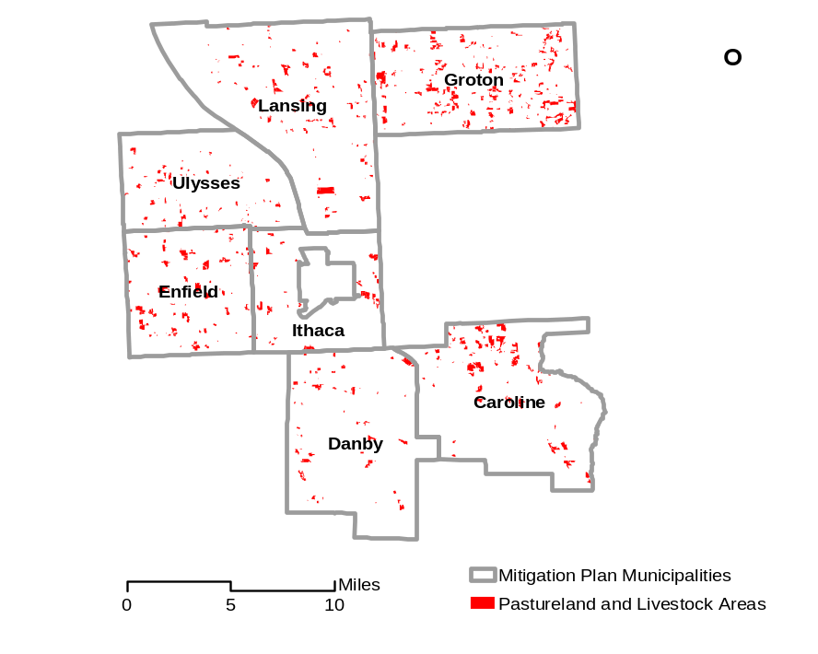

Essentially, all humans that reside in, or otherwise depend upon agriculture from, Tompkins County, are potentially susceptible to the direct (e.g., lost livestock and crops, illness from consumption of infected food) and indirect (e.g., regional economic downturn) impacts associated with an agricultural epidemic. The nature and type of impact to crops, livestock or humans would vary depending on the disease vector.
Source: HAZUS-MH (FEMA 2004)
The County does not have data on agricultural infrastructure and HAZUS-MH includes limited information on agricultural facilities. Impacts to facilities associated with an epidemic (agriculture) hazard event are difficult to estimate. One can anticipate that costs associated with facilities would include decontamination of impacted areas, rather than destruction of buildings entirely.

Damages and losses that might accompany the epidemic (agricultural) hazard as related to human disease outbreak are primarily limited to effects on humans associated with treating or managing impacted animal populations. Human impacts are anticipated to be minor based on available data. Primary damages or losses associated with an outbreak or outbreaks could include economic losses associated with lost productivity; social losses associated with economic loss, disease, and fatality in the community; adverse impacts on animal hospitals and other animal health care facilities and staff; fear and anxiety associated with the outbreak; and costs to manage impacted crops and animals and decontaminate facilities.

Additional Data and Next Steps

Various algorithms have been developed to predict the spread of disease in large human and animal populations; however, modeling of outbreak occurrence and probability is not appropriate given the data currently available and the resources available to complete this plan. Also, information is considered sufficient to demonstrate risk is significant to the community and to identify mitigation strategies. To help predict and model future events, the planning group will work closely with USDA and local representatives to maintain current data on epidemic hazards, potential impacts and preventive measures (see also Section 5, mitigation strategies).

If value information was available for crops (for example, dollar value per acre for various crops) and specific crop and cattle grazing acreages were up to date, an estimate of loss based on assumptions regarding the probability of impact could be made using the percentage loss assumptions discussed earlier and described in FEMA guidance. The planning group will discuss the feasibility and value of such data, weighed against the likelihood of this hazard compared to other hazard events. Such data could also support the evaluation of flood damage to crops and similar evaluations for other hazards that can impact crop and pasture lands.

Overall Vulnerability Assessment

Agricultural epidemics are not considered highly likely to affect large tracts or numbers of animals in the study area; however, the dependence of the local economy on agriculture is such that an epidemic could have a major adverse impact on Tompkins County and the municipalities. Infrastructure, building stock, and critical facilities are not likely to be affected by agricultural epidemic, although decontamination and disposal of impacted crops and animals could be costly if a major epidemic occurred. Mitigation activities in Section 5 focus on prevention and education.
4.4.1.5 Epidemic (Human)
The epidemic (human) hazard in Tompkins County is generally considered to be elevated relative to other communities in the region based on the presence of Cornell University, which is attended by numerous international students, researchers, and faculty, many of whom travel frequently. According to Alice Cole, the Director of Public Health for Tompkins County, there has been no major human disease outbreak in Tompkins County in recent memory. Further, the county and municipalities have implemented contingency plans and protocols to enable rapid response to, and control of, outbreaks if identified. A good example of emergency preparedness for this hazard was the Cornell University graduation exercise of 2003, which was attended by many people from China and other Asian countries. During this period, these countries were experiencing an outbreak of Severe Acute Respiratory Syndrome (SARS). Prior to the graduation, the Tompkins County Public Health Department worked with local hospitals, clinics, and university officials to educate them on the signs and symptoms of SARS and to identify quarantine and control procedures if cases were identified. No cases occurred in Tompkins County.

Data Collected and Used

Data to support the analysis of this hazard included recent data made available about the outbreak of SARS, including data on the World Wide Web, data provided by Ms. Alice Cole of the Tompkins County Public Health Department, the New York State Department of Health, and other sources.

Exposure and Loss Estimation

The recent concern over the SARS was felt strongly in Tompkins County, as preparations were made by the Tompkins County Health Department to prevent the potential spread of the disease by students and others attending the Cornell University graduation ceremonies from China, the presumed origin of the disease.

According to Ms. Alice Cole, New York State Department of Health was the primary source of precautionary measures against the SARS outbreak (Cole 2004b). The estimated cost of preparation for a potential SARS outbreak at the 2003 Cornell and Ithaca College graduations was $2000.00. This breaks down to 14 hours of Director of Patient Services time, 10 hours of a nursing supervisor, 24 hours of a community health nurse, 5 hours of the Public Health Director, and 2 hours of a Sr. Clerk. It does not include the costs for the County Public Health Department and first responders who were on call 24/7. There were no reported SARS cases in this area. If there had been, the on call time would have increased and response measures would have been implemented.

Estimating the cost of a reaction to a human epidemic incident has too many variables to calculate. In a true epidemic, Tompkins County would need to initiate a mass vaccination clinic that would draw on a multitude of volunteers and other local, state, and potentially federal organizations to provide manpower, equipment, and supplies.

Tompkins County has implemented a Health Emergency Operations Plan that outlines measures to be taken in the event of an outbreak, including information on response protocol for hundreds of diseases. A similar state plan outlines measures that counties should undertake in the event of a bioterrorist attack.

Epidemic risks are assessed for human populations by mathematically modeling the possible initial occurrence, spread, and effect on the population potentially exposed to a disease. Various algorithms have been developed to predict the spread of disease in large human and animal populations; however, modeling of outbreak occurrence and probability is not appropriate given the data currently available and the resources available to develop this plan. The evaluation of epidemiology in Tompkins County was considered beyond the scope of this assessment.

Potentially the entire population of Tompkins County could be exposed. Table 4-4-13 identifies the population in Tompkins County, based on 2000 Census data. It also shows socially vulnerable populations, including the population over age 65, which is more susceptible to disease and the population with household incomes of less than $20,000 per household annually, which may be more susceptible should an event occur due to lack of insurance, lack of knowledge regarding preventive measures, and other factors. Another category of vulnerability includes children and pregnant women and mitigation measures will also focus on prevention and response efforts to assist these populations should an event occur. For this hazard, it should be noted that some towns, such as the Town of Ithaca, have transient populations that may not be recorded in the Census data and that can bring infections and disease from other continents (student and professor population). However, mitigation plans already in place and international and other measures should help prevent epidemic issues associated with this population (for example, no SARS events occurred in the area, although the university population includes Asian students).

Table 4-4-13. Populations in Study Area Exposed to Epidemic (Human)
Town | Population Over Age 65 | Population With Income Less Than $20k/yr. | Total Population In Study Area
Caroline | 240 | 215 | 2,910
Danby | 321 | 179 | 3,007
Enfield | 337 | 274 | 3,369
Groton | 691 | 398 | 5,794
Ithaca | 2,064 | 1,510 | 18,710
Lansing | 1,191 | 582 | 10,521
Ulysses | 700 | 386 | 4,775
Study Area | 5,544 | 3,544 | 49,086

Data was not available to estimate losses associated with the epidemic hazard for humans in Tompkins County; however, all persons that reside in the study area are at some risk of developing a disease in the event that an outbreak occurs. Damages and losses that might accompany this hazard are primarily limited to effects on human populations and health. Structures, utilities, or transportation facilities would not likely be directly affected by epidemic, although the work load and supplies for public health and safety facilities could be impacted. In addition, decontamination of impacted buildings and equipment might be necessary.

Primary damages or losses associated with an epidemic event could include economic losses associated with lost work days or productivity due to disease; social losses associated with disease and fatality in the community; adverse impacts on hospitals and other health care facilities and staff; fear and anxiety associated with the outbreak, and potentially loss of life. In addition, structures, furnishings, and belongings that come into contact with a diseased person may need to be destroyed should these resources be considered infectious.

Additional Data and Next Steps

The epidemic (human) hazard was raised as a concern by the community; therefore, it is included as a hazard under the requirements of DMA 2000. However, the evaluation of the risk associated with the epidemic hazard is limited to the presentation of potentially exposed population and support structures and functions at this time.

Because the type of disease or affliction that might cause an epidemic is difficult to predict and the area of impact is difficult to define, the entire population of Tompkins County is susceptible to this hazard. Tompkins County Public Health Department maintains health records for Tompkins County. If specific diseases are evaluated and immunization records are available, the exposed population would be the non-immunized fraction of the population. In some areas where health care is inadequate or persons are uninsured, there have been cases of disease outbreaks among non-immunized children and others.

The costs of immunization, health care, emergency response, and other associated elements could be estimated based on professional judgment and discussions with health professionals. Also, based on a review of current preparedness efforts, disease control and prevention measures already in place appear to be effective in preventing or reducing the impact of a potential epidemic.

Resources that could assist the community in predicting and preparing for human epidemics might include the following:

- Cost of prevention and cure data for various diseases.
- Historic information on, and statistical models developed to predict, outbreak frequency, magnitude, and occurrence from various health organizations (such as the U.S. Centers for Disease Control and Prevention [CDC], World Health Organization [WHO], and New York State Department of Health)
- Records of disease occurrence, type, and frequency in Tompkins County from local hospitals and the county health department
- Frequency or amount of travel, import of goods, or other physical interaction with other, particularly international, communities
- Precautionary measures and prevention-related communication implemented by the jurisdictional health and agricultural departments
- Amount, type, and frequency of immunization for various diseases
- Public health considerations of the communities, including nutrition, sanitation, water quality, response capabilities of various health management agencies, etc.

Collecting or compiling such data would assist Tompkins County to estimate the financial and health impact of an epidemic on support service sectors and the population.

Overall Vulnerability Assessment

Human epidemics are not considered highly likely to affect the study area; however, as many students and faculty of Cornell University frequently travel internationally, the potential for a disease outbreak is considered higher than in other nearby counties. Public health programs are currently in place including procedures and policies designed to respond rapidly to, and control the spread of, disease in the community. Infrastructure, building stock, and critical facilities are not likely to be affected by epidemic, although heath care and emergency response personnel and facility resources could be stressed.

4.4.1.6 Fire (Urban and Wild)

Urban fire is a concern wherever concentrations of population and buildings are present. The effects of urban fire can be significant, but are generally localized to one or two city blocks. Wildfires can impact a greater area, but in the Tompkins County area, seasonal rainfall is generally adequate to prevent wildfire and areas of development in Tompkins County generally are not located in wildfire hazard areas. However, increasing and planned development may increase the wildfire and urban hazards in particular towns within the study area.

Data Collected and Used

Data available regarding the fire hazard included input from town and county officials, the American Red Cross (ARC), NOAA’s NCDC databases, Tompkins County land use data, HAZUS-MH, and the HAZNY documentation for this area.

Exposure and Loss Estimation

NOAA’s NCDC maintains records of wildfires in Tompkins County for the period since 1950. According to the NCDC website, no significant wildfires were reported for Tompkins during this period. The climate of Tompkins County is not conducive to large-scale drought and dry climate vegetation that are primary causes of the massive and highly destructive wildfires that occur periodically in the Western United States. However, several major structural fires have occurred in Tompkins County in the recent past that have resulted in the complete loss of homes, businesses, and community resources, as described in the Hazard Profile section. In addition to inventory loss and damage, which can be complete, structural fires can cause serious injury and death, and strain public safety services such as fire departments, hospitals, and water supplies. A major concern in some areas of Tompkins County and the municipalities is the availability of fire suppression equipment and infrastructure (e.g., fire hydrants and water sources) for rural populations.

Textual documentation of historic urban and wild land fires is available from HAZNY, including location, area burned, costs in dollars of damages, and associated injuries and deaths. In addition, the Tompkins County Fire Prevention Bureau and local fire departments within the various towns maintain records of calls, damages, and circumstances that can be used to support an evaluation. Wildfire is a function of moisture (or lack thereof), fuel and local topography. Precipitation data were assessed to evaluate the likelihood that a major wildfire could occur during a certain period of time. Vegetative cover and land use maps were evaluated to estimate the amount and type of fuel that might sustain a wildfire and to represent areas that might be prone, or exposed, to the fire hazard. Inventory data contained in HAZUS-MH supports exposure estimates for this hazard.

In July 1998 in the Town of Danby, a fire along Bald Hill Road destroyed a major business resulting in the loss of 10 jobs and several lumber mill buildings. In June 1999, a fire in Central Danby resulted in the loss of the only convenience store and gas station in town as well as five local jobs. Danby reported several smaller fires that damaged farm properties in 2002 (Tompkins County 2003e). In September 2003, the Cayuga Addiction Recovery Services (formerly Alpha House) facility (60 bed) in the Town of Ulysses burned down. The fire hydrants near the facility were not in service because of low pressure when the fire occurred.
Urban areas have the potential for significant damage to infrastructure, loss of life, and strain on existing healthcare facilities and emergency responders based on high structural and population densities. While the majority of urban areas and associated fire events in Tompkins County are located in the City of Ithaca (which is not within the scope of this plan), urban areas within the study area include the population centers of the Towns of Ithaca, Lansing, Groton and Ulysses (see Figure 4-4-12). Structural fires typically impact individual or closely clustered buildings. Building densities are included in Section 4.3 of this plan.
Wide-reaching woodland fires, though uncommon in the region, would be more likely to strike heavily forested areas during dry periods. Figure 4-4-12 also shows forested areas.

Figure 4-4-12. Urban and Wild Land Fire Hazard Areas in Tompkins County Multi-Jurisdictional Study Area

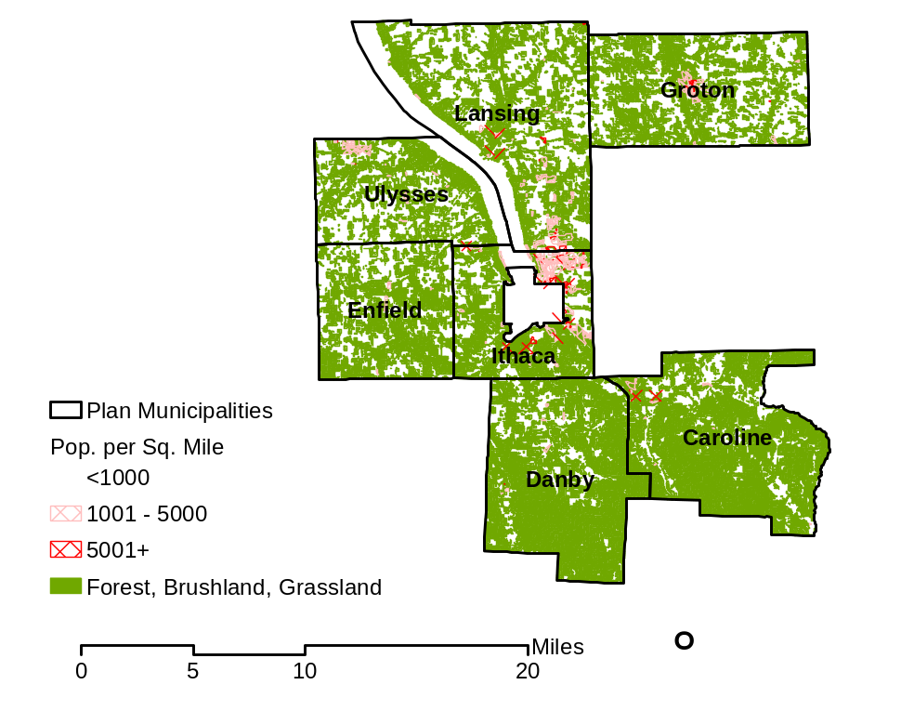
Source: HAZUS-MH (FEMA 2004)
Urban fires occur occasionally in the study area; the effects are local (that is, generally constrained to a limited geographic area), but can be acute within the localized area (resulting in major or complete destruction of building structure or content). Losses and impacts to the structures, critical facilities, and utilities would be local and short in duration, though potentially could have a high impact on individual structures and facilities. Such fires also can result in injury and death. Problems that exacerbate the urban fire hazard include the facts that many homes and other structures in the area are antiquated and remote from services. Existing and future mitigation efforts such as those presented in Section 5 should continue to be developed and employed so that the study area is prepared for these events when they occur.
Table 4-4-14 identifies the medium and high-density residential structures and building count of commercial buildings that are considered at risk for urban fire damage for each participating jurisdiction and Table 4-4-15 identifies their exposure values.
Table 4-4-14. Inventory of Medium and High-Density Res. Structures and Commercial Building Stock for Urban Fire Hazard
Town | Total Residential Structures | Medium and High-  Density Residential  StructuresTotal | % of Total  Residential Structures | Commercial  Total | Total of Medium and High- Density Residential and Commercial Structures  At Risk
Caroline | 998 | 33 | 3.31% | 0 | 33
Danby | 977 | 39 | 3.99% | 1 | 40
Enfield | 1,160 | 17 | 1.46% | 1 | 18
Groton | 1,781 | 69 | 3.86% | 5 | 74
Ithaca | 3,813 | 494 | 12.87% | 24 | 518
Lansing | 3,125 | 200 | 6.32% | 40 | 240
Ulysses | 1,679 | 75 | 4.43% | 10 | 85
Study Area | 13,533 | 927 | 6.8% | 81 | 1008
Source: HAZUS-MH (FEMA 2004)

Table 4-4-15. Valuation of Med. and High-Density Res. Structures and Comm. Building Stock Exposure for Urban Fire Hazard
Town | Total Residential Structure Value  ($M) | Medium and High-Density  Residential Structure Value  ($M) | % of Total  Residential  Value | Commercial  Total  ($M) | Total Structures at Risk  ($M)
Caroline | 134 | 20 | 14.68% | 1 | 21
Danby | 132 | 16 | 12.18% | 5 | 21
Enfield | 122 | 14 | 11.54% | 4 | 18
Groton | 231 | 40 | 17.22% | 17 | 57
Ithaca | 919 | 441 | 48.05% | 65 | 506
Lansing | 555 | 162 | 29.19% | 87 | 249
Ulysses | 249 | 40 | 15.84% | 24 | 64
Study Area | 2,340 | 733 | 31% | 200 | 933
Source: HAZUS-MH (FEMA 2004)

Table 4-4-16 identifies the estimated losses that could result from 1%, 5%, 10%, and 20% damage losses for the high-density residential structures and commercial building stock in the Tompkins County Multi-Jurisdictional Study Area. This estimate is extremely conservative given that only a limited geographic area will be impacted by each urban fire.

Table 4-4-16. Potential High-Density and Commercial Losses from Urban Fire in Tompkins County Study Area
Town | Total Structure Value at Risk  ($M) | 1% Damage Loss Estimate ($M) | 5% Damage Loss  Estimate ($M) | 10% Damage Loss  Estimate ($M) | 20% Damage Loss  Estimate ($M)
Caroline | 21 | 0.21 | 1.05 | 2.1 | 4.2
Danby | 21 | 0.21 | 1.05 | 2.1 | 4.2
Enfield | 18 | 0.18 | 0.9 | 1.8 | 3.6
Groton | 57 | 0.57 | 2.85 | 5.7 | 11.4
Ithaca | 506 | 5.06 | 25.3 | 50.6 | 101.4
Lansing | 249 | 2.49 | 12.45 | 24.9 | 49.8
Ulysses | 64 | 0.64 | 3.2 | 6.4 | 12.8
Study Area | 933 | 9.33 | 46.65 | 93.3 | 186.6
Source: HAZUS-MH (FEMA 2004)

Additional Data and Next Steps

Data regarding the construction characteristics of structures in the study area, such as primary building materials used (e.g., wood vs. brick, fire detection equipment, age, etc.), proximity to forested areas, and availability of fire suppression infrastructure should be identified for further evaluation. Due to insufficient data, a full loss estimate was not completed for the fire hazard. Based on readily available information, all structures in Tompkins County are at some risk of being destroyed or seriously damaged by a fire.

The percentage exposure estimate presented on the previous page is based on a methodology presented in FEMA’s How To Series (FEMA 386-2), Understanding Your Risk, Identifying and Estimating Losses (FEMA 2001) and FEMA’s Using HAZUS-MH for Risk Assessment (FEMA 433) (FEMA 2004). For the urban fire hazard it provides a conservative estimate. Another means to analyze this fire risk is to estimate the value of property on one city block. For example, a highly developed block would present a conservative, yet more realistic estimate of impact from an urban fire event (see Additional Data and Next Steps).

Once additional valuation data for critical infrastructures is obtained, including data for schools, nursing homes, and other infrastructure that may be located in the more densely populated areas of the multi-jurisdictional study area, the data in HAZUS-MH can be modified to include accurate local valuation data and can be used to estimate exposure for these assets.

The FEMA fuel model maps do not provide sufficient information to identify specific wildfire hazard areas to perform an exposure assessment for the urban-wildfire interface areas. Wildfire hazard maps were not readily available and will be required to identify the geographic locations where wildfires have taken place in the past and areas prone to wildfires. With increasing development near forest lands, a greater focus on the wildfire hazard may be warranted.

Overall Assessment
Buildings constructed of wood are generally more likely to be impacted by fire than buildings constructed with bricks or concrete. While it is not possible to predict when and where a fire will start, the Tompkins County Fire Department is well-equipped and prepared to respond to fires as they arise. Large-scale wildfires are considered unlikely to occur in the area due to the amount of moisture stored in the vegetation, topography, and the amount of precipitation that the area receives annually. The status of fire risk in the county and municipalities will continue to be monitored and ongoing and new mitigation efforts to prevent fires and control them when they arise will continue to be developed.

Technological Hazards

This section addresses the technological hazard, utility failure.

Utility Failure

Our society is heavily dependent upon electricity, telecommunications, and other utilities for our productivity and lives. Utility failures can be associated with regional grid failures, windstorms, ice and snow storms, flooding (mostly problematic for water and wastewater treatment systems), damaged equipment and disrupted infrastructure, weather conditions, vehicular accidents, and downed power lines, among other causes, and can disrupt our ability to do work, communicate, and commute. In some cases, utility failure can affect our health by affecting our ability to control temperature. In most cases, the losses and damages associated with utility failure are associated more with delays, lost productivity, stressed public safety infrastructure, and repair costs than lost infrastructure.

Data Collected and Used

Data for power outages was obtained from national news reports regarding major power outages, county and local officials, and utility representatives, as feasible. Historically, data on events is tracked, but specific data on losses associated with power outages are often considered as part of the natural hazard events that cause the outage (for example, if a hurricane occurs, the power outage losses may be tracked with other losses for the hurricane event); therefore, limited historic loss data is available for this hazard.

Exposure and Loss Estimation

Like many areas in the Northeast, the utility infrastructure of Tompkins County and the seven jurisdictions is aging and subject to outages, as illustrated by the major regional blackout that left millions of people without power during the summer of 2003, and resulted in millions of dollars in lost productivity and other costs. Utility failure can be highly localized, as well, such as certain power outages due to fallen electrical lines or faulty substations or transformers.

Utility failure presents a serious local problem to Tompkins County and the municipalities, as outages can endure for several days and the loss of power in some areas can leave thousands of people, including the elderly, infirm, and immobile, without heat, air conditioning, cooked food, clean water, telephone connections, and other necessities. Also, many private wells in the region are powered by electric pumps that do not operate during power outages, leaving people without their usual water supply. Information was provided by a representative of the City of Ithaca Water Treatment Plant regarding concerns associated with this hazard. This information is presented below to illustrate the types of concerns associated with power outages in the study area.

According to Chuck Baker of the City of Ithaca Water Treatment Plant, this plant has experienced outages lasting from 2 to 6 hours over the years. The severity of the impact of each outage depends upon when it occurs (time of day and year) and can impact different water supply zones based on it’s water pressure impacts. The city plant has a small backup generator but it cannot run all of the treatment processes. Also, the backup generator does not operate the pumps that provide water to two higher pressure zones. As a result, the city is limited in the amount of water that it can treat and supply to the system during an outage. Therefore, the city is currently evaluating internal projects that would allow on-line monitoring and control of the system to remain active during a power outage. The city also has implemented the infrastructure to support a larger generator at the plant, but currently does not have a larger generator on-site, nor is there a portable generator in the area that would be sufficient to meet all of the plant’s power needs during an outage. Impacts to the plant and area during an outage also depend on whether the outage impacts just the plant or if it impacts the entire area. If all three water suppliers in the area are affected, emergency options become more limited. A large backup generator that would supply the current facility and pump station at Water Street would cost from $80,000 to $150,000. A long-term outage would greatly affect the plant, depending upon the incoming raw water quality to the plant and the difficulties in keeping the higher lift areas supplied. The city does have a remote pump station that has a trailer-mounted generator that could be moved to the site to run some operations during a major power outage.

There have also been problems with the plant itself beyond the electrical grid. One of the main issues has been the loss of the raw water line due to landslides (mudslides). The main line has been taken out of service two to three times since it was first installed. The area through which the line runs is prone to landslides and the area is quite inaccessible at some points. If another landslide event occurred, it could take weeks to repair the line and restore operations and several hundred thousand to over 1 million dollars to complete a repair and restoration to the area. The City of Ithaca Water Treatment plant’s line runs through the Mulholland Wildflower Preserve. In some spots a large crane would be necessary for the repairs. Additionally, the plant itself has parts that are over 100 years old. Due to age of the plant and the water line inaccessibility, there are a number of components that could break and cause the plant to operate at a reduced level. The plant has made additions that support operations in case one component breaks and this provides operational readiness for some situations that could occur. If the city plan cannot produce enough water, it can purchase water from nearby suppliers; but this has economic impacts for the plant and community.

All facilities and resources in Tompkins County that require electricity, gas, telecommunications, and other utilities to provide light, heat, water, etc., including homes, businesses, government facilities, and critical facilities, are vulnerable to problems associated with utility failure.

Table 4-4-17, based on HAZUS-MH data, summarizes the population over the age of 65 as determined by the U.S. Census Bureau. This population is considered particularly vulnerable to power outages in the summer or winter because the older population is less able to respond to such situations and more susceptible to ill effects from extreme heat or cold. Figure 4-4-13 shows the distribution of this population.

Table 4-4-17. Vulnerable Population in Tompkins County
Multi-Jurisdictional Study Area to Utility Failure
Town | Population over age 65
Caroline | 240
Danby | 321
Enfield | 337
Groton | 691
Ithaca | 2,064
Lansing | 1,191
Ulysses | 700
Study Area | 5,544

Figure 4-4-13. Distribution of Elderly Population for Tompkins County Multi-Jurisdictional Study Area

Table 4-4-18 presents potable water data for Tompkins County and Table 4-4-19 summarizes access to the public water supply; this indicates the populations vulnerable to water supply outages or contamination issues associated with a power outage, depending on the supplier impacted.

Table 4-4-18. Potable Water Supply Data
System | Population Served | Water Source
Bolton Point WTP | 30,000 | Cayuga Lake (surface water)
City of Ithaca WTP | 35,000 | Six Mile Creek (surface water)
Cornell WTP | 27,000 | Fall Creek (surface water)
Village of Groton WTP | 2,500 | Wells / infiltration gallery
Village of Trumansburg | 2,300 | Wells
Village of Newfield | 2,000 | Wells
West Danby | 270 | Wells
Data provided by Tompkins County Public Health Department (2004). Notes: WTP – Water treatment plant

Table 4-4-19. Public Water Supply Access to Tompkins County Multi-Jurisdictional Study Area
Town | Population (1) | Access to Public Water Supply
Town | Population (1) | Total | Percent
Caroline | 2,910 | 0 | 0.00%
Danby | 3,007 | 218 | 7.25%
Enfield | 3,369 | 0 | 0.00%
Groton | 5,794 | 1,936 | 33.41%
Ithaca | 18,198 | 17,296 | 95.04%
Lansing | 10,521 | 7,716 | 73.34%
Ulysses | 4,775 | 1,811 | 37.93%
Source: HAZUS-MH Build 34; Data is Version 1.0 - January 2004. Note: (1) Determined as population of those census blocks that intersect the potable water supply lines provided by Tompkins County, which may result in a somewhat lower than actual figure. For example, the Village of Groton water supplier states that it serves a population of 2,500. The Village of Trumansburg water supply (Ulysses) states that it serves 2,300.

Additional Data and Next Steps

Data to support estimates of the probability of future events is limited. Also, the power outage hazard event often is a cascading event triggered by other hazards. Utilities maintain records of power lines, substations, pipelines, distribution systems, maintenance locations, equipment, roads, easements, users, and other inventory. Utility data often are difficult to obtain and update as they are owned by private companies concerned about data security. However, available data were reviewed, where allowed, from public and private utilities regarding the dates, geographic extent, nature, duration, and cause of historic utility failures.

Based on available data, certain areas, such as older communities and water supply systems, can be more susceptible than others to power outages and other utility failures. Data on the estimated costs associated with previous utility failures is not currently available; however, while costs associated with certain elements of a failure, including lost time at work, lost revenue by the affected utility, and lost productivity can be estimated using professional judgment and assumptions, data are currently insufficient for such an assessment to be conducted for the study area.

As discussed above, data are currently insufficient to estimate losses associated with the utility failure technological hazard in Tompkins County and the municipalities. In the future, utility failure records can could be obtained and evaluated to determine the locations and conditions most commonly associated with outages. Most utilities have developed GIS layers of their distribution systems that could be integrated into HAZUS-MH if they were shared with the county. In some cases, the entire region may be affected. If the frequency, duration, affected locations, and geographic extent of previous utility failures could be statistically evaluated and correlated with geographic (e.g., topographic) maps, areas with the highest exposure to problems associated with traffic accidents can be determined. Based on the number of people and facilities affected by a utility failure, certain assumptions can be made regarding the costs associated with lost productivity (for example, hours away from work for individuals and lost industrial productivity, etc.). Historic data could be used to help identify such costs and predict areas of particular vulnerability to this hazard in a qualitative or quantitative manner.

Additionally data that would support analysis of this hazard or the analysis of mitigation options would include data regarding values for different components of power plants, water treatment plants, electrical transmission lines, utility poles, telephone transmission lines, piping, and items such as generators to identify the costs of basic repairs and upgrades to mitigate potential future utility failures. For utility failure events that damage or destroy plant components, cost data would support estimates of items lost and associated costs or assumptions regarding percent damage that could be caused by various events. The county could then estimate the percent damage anticipated and multiply that value by the total value of the plant or system impact to identify the loss value/damage estimate. This methodology is based on FEMA’s How To Series (FEMA 386-2), Understanding Your Risks, Identifying and Estimating Losses (FEMA 2001) and FEMA’s Using HAZUS-MH for Risk Assessment (FEMA 433) (FEMA 2004). Other costs associated with this hazard are less easily defined such as environmental impacts (should waste water be passed through the plant or any utility pipeline burst and cause a Hazmat spill).

Overall Vulnerability Assessment

Utility failures are relatively common and difficult to predict in the study area. The impacts of utility failure can range from nuisance when they are short-term to major regional problems when they last for longer periods (especially during periods of extremely hot or cold weather). Existing and future mitigation efforts will continue to be developed and employed to prepare the study area for such events (see Section 5 for examples and a discussion of mitigation strategies for the utility failure hazard).

4.4.3 Human-Caused Hazards

This section addresses human-caused hazards, including: transportation accidents (including Hazmat release in transit), water supply contamination, terrorism, and civil unrest.

4.4.3.1 Transportation Accident (Including Hazmat Release [In Transit])

The transportation accident hazard can cause injuries, fatalities, impacts to public infrastructure and environmental damage (where hazard materials are released). Because transportation is a human-driven function, this hazard is discussed as a human-caused hazard.

Data Collected and Used

For this hazard, data was obtained from the county and local town officials. These representatives work with the state and other agencies to track and report transportation incidents in the study area. New York Department of Motor Vehicle data and U.S. Coast Guard data also was obtained and reviewed.

Exposure and Loss Estimation

Significant losses and damages that can be associated with major transportation system disruptions, including releases of Hazmat that occur in transit, in the study area include the following potential impacts:

- Injuries, including fatalities, associated with accidents, especially in association with other hazards evaluated in this document (e.g., ice storms, severe winter storms, and flooding)
- Losses and damages to assets such as automobiles and infrastructure from direct impact during accidents
- Increased pressure on public safety infrastructure, such as Hazmat response teams, police, fire, and medical and rescue personnel, as well as community funds associated with emergency response
- Disruptions and potentially lengthy delays for motorists behind the accidents, and increased traffic on alternative routes and detours
- Impacts to environmental media, including surface water, soil, groundwater, and air from Hazmat contamination, plus associated cleanup costs
- Losses and damages to assets such as vehicles and infrastructure from direct exposure to chemicals during accidents

Data are not currently available to support estimation of future events, damages and losses due to transportation accidents or hazardous material [releases] in transit. Past event data is limited and as traffic and development increase, past data may not provide a reasonable estimation of future probability.

Due to the nature of traffic accidents, all persons that travel within the study area are theoretically at some risk of being affected directly by a traffic accident or Hazmat release in transit or cascade effects, such as utility disruptions, lost productivity, water supply contamination, or temporary delay or lack of emergency services. Certain intersections and stretches of roads are often susceptible to large-scale traffic accidents and disruptions.

Traffic accidents occur relatively frequently in Tompkins County and the municipalities, as in other localities. Annotated information regarding the number and damages associated with specific accidents was not available for this plan. However, anecdotal and some specific data are available and discussed in this section.

Events that have occurred in the study area include:

- In 1991, a multiple vehicle accident involving a Greyhound bus over-burdened emergency response services, as did another bus accident along Route 13 in the Town of Ithaca (near K-Mart and Ithaca Shopping Plaza) in 2001 (Tompkins County 2003e).
- A fuel truck overturned along Route 96 in the town of Ulysses in 1988.
- In the Town of Danby, a Conrail train derailment and fuel spill from locomotives caused water supply contamination in 1997. Flooding caused by beaver dams washed out Conrail track supports, causing three locomotives to derail, with 7,000 gallons of diesel fuel leaking out of ruptured fuel tanks. This resulted in a fish kill along a portion of Cayuga Inlet Creek noted for its trout fishing (Beeners 2004d). Also there have been multiple fuel truck overturns along State Route 34/96.
- Several fuel trucks have also overturned resulting in chemical releases (1998 and June 29, 2001). (Tompkins HAZNY, 2003)

No cost or damage information associated with Hazmat releases in the study area was available for review.

According to data provided by the Division of Motor Vehicles (DMV), between 1991 and 2001 there were 6 fatal accidents, 740 personal injury accidents, 1,024 accident injuries, 1,815 property damage accidents, and 2,561 total reportable accidents (NY DMV 2002). Loss values were not provided with the DMV data.

Areas that are likely to be the most vulnerable to problems associated with a major transportation accident or Hazmat release that occurs in transit are major highways, such as State Highway 13, where speeds are generally high, slopes and curves are present, lighting is not present for night driving, trucks are common (including tankers), and long distance travelers that may not be aware of local hazards are present. In addition, roads that cross water bodies, bridges, and areas with steep slopes and tight curves are commonly the sites of accidents.

Certain intersections and stretches of roads are often more susceptible than others to accidents and subsequent release of Hazmat from tanker trucks and other vessels. The database of reported releases of oil and hazardous substances maintained by the National Response Center, an office of the U.S. Coast Guard, indicates that several mobile Hazmat responses have occurred in Tompkins County since 1990, including several along State Highway 13.

The designated hazard areas include all traveled roadways in Tompkins County, especially major roadways and arteries. Of particular concern are areas that are difficult to navigate, conducive to accidents, or historically accident-prone. Roadways adjacent to water bodies or that cross populated or highly traveled areas, such as town centers and State Route 13, present concern in terms of the greater impacts that events in these areas can have on the environment and humans. An additional area of concern is the intersection of Route 13 and Triphammer Road due to congestion, increased road trips and pedestrian safety. Figure 4-4-14 shows major roadways in Tompkins County and the municipalities. Figure 4-4-15 shows locations where transportation routes cross water supply areas in Tompkins County.

Areas of concern for this hazard also include particular routes, such as roads that trucks use to travel in and out of Tompkins County. Areas along these routes that are conducive to accidents could be identified and mapped to determine the locations of sensitive areas that can be affected, the percentage of population that could be at risk, and whether there are sufficient resources available to handle the cleanup and remediation of any spill or release. For example, the main bridge on the roadway out of Lansing over Salmon Creek is a designated transportation hazard area and runs near schools and a major thoroughfare (Bud Shattuck, 2004). Figure 4-4-16 identifies railroad transportation routes that intersect with major water bodies in the study area.

Figure 4-4-14. Major Roadways in Tompkins County

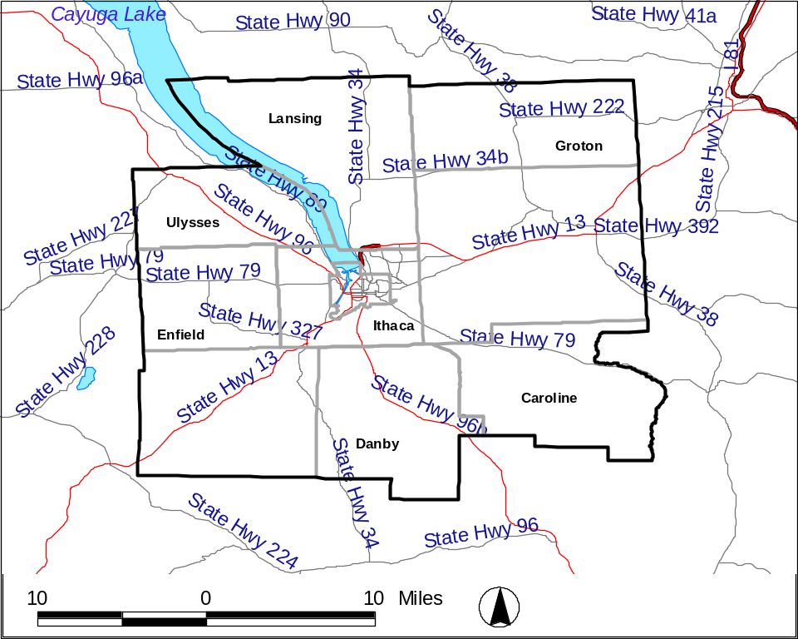
Source: HAZUS-MH (FEMA 2003b)

Figure 4-4-15. Locations Where Transportation Routes Transect Water Supply Areas in Tompkins County
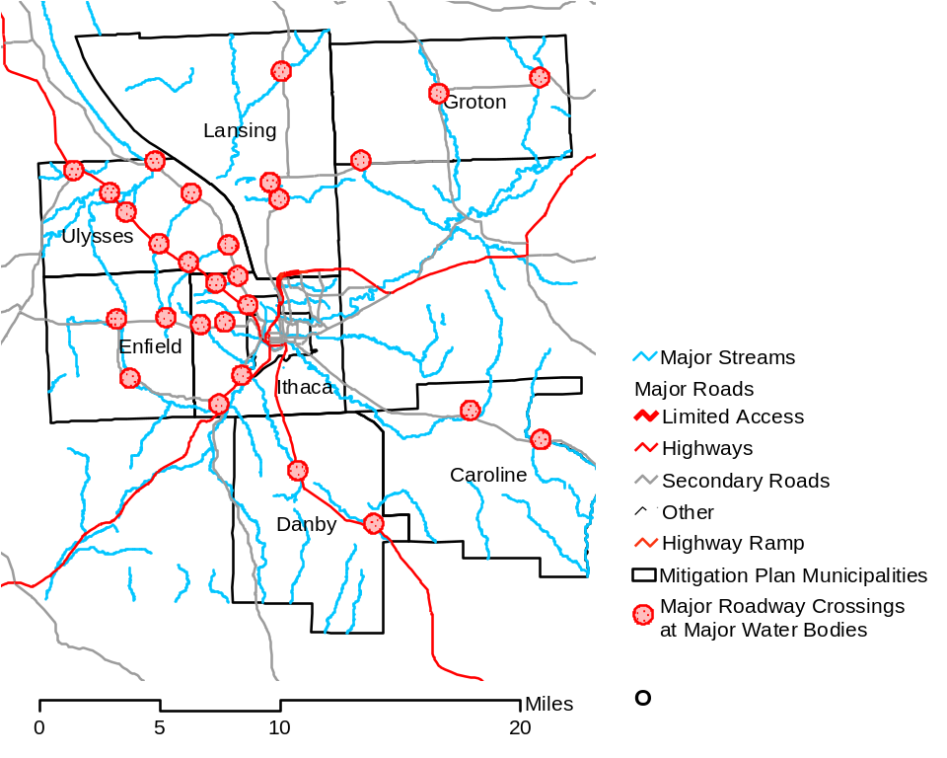
Source: HAZUS-MH (FEMA 2003b)

Figure 4-4-16. Locations Where Railroad Lines Interface with Water Bodies

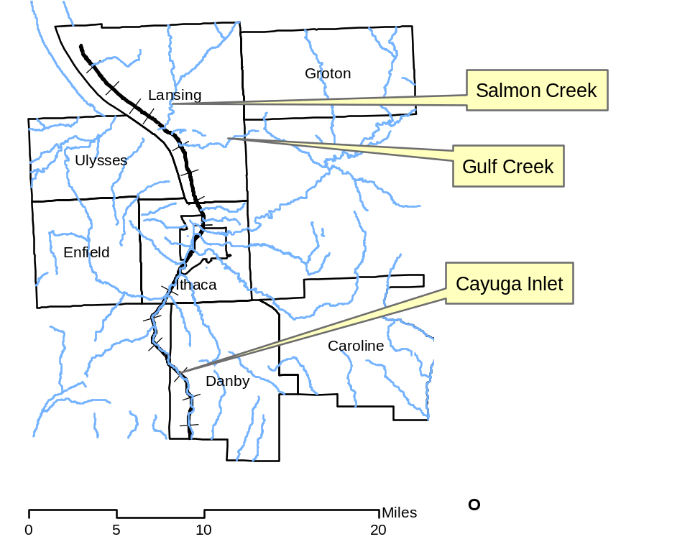
Source: HAZUS-MH (FEMA 2003b)
Additional Data and Next Steps

Since data are not currently available to enable estimation of damages and losses due to transportation accidents or Hazmat [releases] in transit, additional data must be collected. Public highway and transportation and public safety departments often maintain records of the locations, dates, conditions, and damages associated with traffic accidents. Traffic records may also be available that describe the number of vehicles that pass through a given point per unit time and the vehicular speeds commonly traveled. A mitigation strategy has been identified to obtain software that would support better tracking of transportation and Hazmat accidents. Additional data could then be analyzed to identify trends and compile valuation data on losses. Other transportation studies of vulnerable areas also have been identified as part of the mitigation activities discussed in Section 5 of this plan.

Additional data could include valuation data for roadways and data on remediation costs for various Hazmat release and response scenarios (such as data from EPA or NYSDEC). For example, if the average cost of a roadway mile, railway segments, and categories of bridges were identified, the valuation of segments of concern could be calculated based on this information; also, costs to modify intersections or roadways of concern could be studied. These costs could be compared to data on remediation and response costs. Resources for obtaining this information include the Federal Highway Administration, DOT, EPA, and NYSDEC.

Various methodologies could be used to study the potential losses for transportation accidents, including: investigating insurance industry methods and data, using professional judgment regarding potential intersections at risk and estimates of future costs based on past costs of incidents in these areas, and tracking actual data using a database and studying trends. The county will evaluate available tools to better track incidents and costs and will work across towns to develop a transportation incident tracking scheme that supports future refinement of the mitigation plan.

Additional studies could include evaluating the building inventory at risk along major transportation corridors, human populations (including particularly vulnerable populations) at risk, identifying and mapping of potentially sensitive environmental areas, and estimating losses that could result from a major traffic event or Hazmat release in those areas.

Overall Vulnerability Assessment

Major transportation accidents and Hazmat releases in transit can occur in the study area, occasionally causing delays of up to several hours, and injuries, fatalities, and environmental and economic impacts (through disruption of travel). Hazmat releases that occur adjacent to water bodies are capable of impacting the water supply of the community. Losses and impacts to roads, structures, facilities, and utilities are generally localized to the site an accident. Existing and future mitigation efforts will enable the study area to reduce the potential for future events (for example, through education, improved signage, changes to speed limits, or modifications to dangerous sections of roadways or intersections) and will help the study area be prepared for these events when they occur (for example, through ongoing emergency response plans, training, and exercises).

4.4.3.2 Water Supply Contamination

For this hazard, data on past events and potential future events is limited. Therefore, a qualitative evaluation of the overall potential impact and risk posed by this hazard is presented.

Data Collected and Used

Data for this hazard was obtained from the county, town officials, the U.S. Coast Guard, EPA, NYDEC, and knowledge of the area.

Exposure and Loss Estimation

Approximately 50 percent of Tompkins County residents use private wells for their drinking water, while the remaining half of Tompkins County residents rely on one of three drinking water treatment plants (WTPs) to supply their drinking water (the Cornell drinking WTP, the City of Ithaca drinking WTP, and the Bolton Point WTP). Potential situations that could impact the water supply of Tompkins County include:

- Physical damage to the water supply or delivery system (breaks in pipes, landslides that block water supply intakes, water treatment etc.)
- Hazardous material releases, spills, and leaks that reach surface water supplies or drinking water aquifers
- Terrorist acts that target the water supply
- Bacterial outbreaks, such as E. coli
- Mechanical problems with the WTP operations (e.g., breakdown of equipment) that disrupt or hinder the timely and safe delivery of clean water

Given the generally lower priority assigned to this hazard by the HAZNY study and the limited data regarding past occurrences and impacts, no specific modeling was conducted for this hazard. However, the general population served by private wells and public supply areas was documented and mapped. Due to the concern about the release of these maps, they are not included in the plan but are available for review by government officials and the public, as necessary, by contacting the Tompkins County Planning Department.

Based on all of the available information available, about 50 percent of the population of Tompkins County (approximately 50,000 people, including residents of Tompkins County from outside the seven town study area) is at risk for private drinking well contamination should an event occur that would impact an entire aquifer. This is considered unlikely, as groundwater hydrology is complex and it is highly unlikely that all wells in a region as large as the study area in Upstate New York would be impacted. Approximately 50 percent of Tompkins County’s population obtains drinking water from one of three WTPs. Because large-scale contamination of drinking water within one of the public sources would likely affect a larger number of people, protection of these supply sources is of significant concern.

Several instances of contamination to the municipal water systems in the Tompkins County study area have been recorded, including:

- 1997 – A fuel oil spill caused a water supply outage at the Cornell WTP for 6 days.
- Prior to 1981 – Both the City of Ithaca and Cornell’s WTPs have been shut down due to high turbidity and fuel oil spills.

In Tompkins County, several incidents of groundwater contamination have resulted from leaking underground storage tanks and industrial and commercial spills. The Village of Groton water supply was threatened by a spill associated with Smith Corona. The water supply of several homes in Jacksonville, located in the Town of Ulysses, was impacted by methyl-t-butyl ether (MTBE) and other gasoline-related constituents beginning approximately 30 years ago (Tompkins County 2003f). Residents used bottled water until April of 2004 when they were connected to the Bolton Point system. The Town of Danby also reports occasional incidents of leaking underground storage tanks in areas with no public water supply. The Shelter Valley water system (in the Town of Newfield) has a history of water supply contamination issues, including numerous do-not-drink orders issued by the Tompkins County Public Health Department (Tompkins County 2003e). The Hazmat response database of the National Response Center (NRC), a department of the U.S. Coast Guard that records responses and incidents involving Hazmat releases for the U.S., lists several incidents involving spills to surface water and land from fixed and mobile sources in Tompkins County since 1990. None of the incidents reported on the database appear likely to result in widespread contamination problems.

According to the Tompkins County Planning Department, the cost of providing alternate water supplies should contamination of a public supply occur and the cost to remediate the water supply could be anywhere from 3 to 5 million dollars. Additionally, it could cost between 1 and 1.5 million dollars to lay new lines and provide infrastructure to provide new communities with public water supply or provide alternate sources of water to existing users.

Vulnerable populations are those that live in areas that receive water supply from the three WTPs, since an affected point location at the supply source will affect people in larger tracks of the study area. In addition, the water bodies that provide water to the WTPs, especially areas adjacent to the WTP intakes, are of concern because impacts at these locations could result in impacts to drinking water delivered by the affected system. Areas where the groundwater is shallow or the soils would allow infiltration of contamination from industry or other sources also are vulnerable (see Figure 4-4-17). Table 4-4-19a summarizes potable water data for Tompkins County and Table 4-4-20 includes a summary of the access of the municipalities to the pubic water supply indicating the populations vulnerable to water supply contamination.

According to Chuck Baker of the City of Ithaca WTP, additional costs are incurred if the city cannot produce enough water and the city has to purchase extra water from a nearby supplier. He stated that these costs would be difficult to quantify at present.

Figure 4-4-17. Surface Water Supply and Water Treatment Facilities for Multi-Jurisdictional Study Area
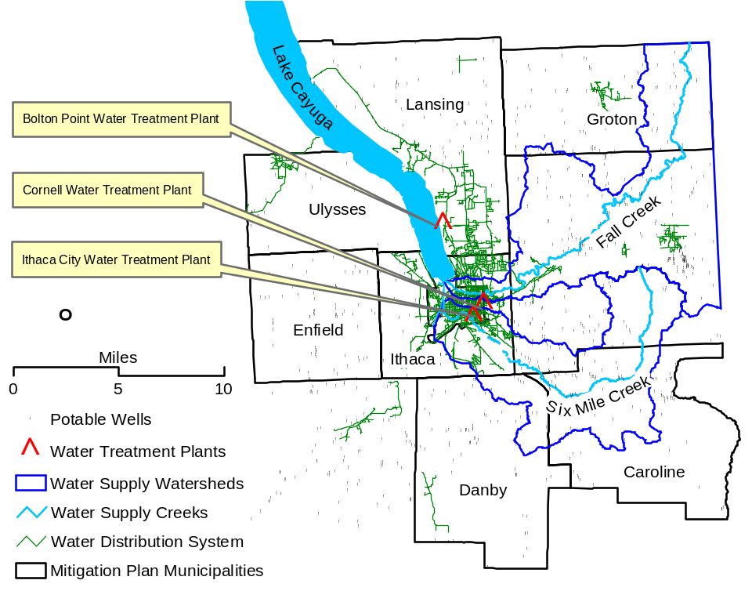
Source: HAZUS-MH (FEMA 2003b)

Table 4-4-19a. Potable Water Supply Data
System | Population Served | Water Source
Bolton Point WTP | 30,000 | Cayuga Lake (surface water)
City of Ithaca WTP | 35,000 | Six Mile Creek (surface water)
Cornell WTP | 27,000 | Fall Creek (surface water)
Village of Groton WTP | 2,500 | Wells / infiltration gallery
Village of Trumansburg | 2,300 | Wells
Village of Newfield | 2,000 | Wells
West Danby | 270 | Wells
Data provided by Tompkins County Public Health Department (2004)
Notes: WTP – Water treatment plant

Table 4-4-20. Public Water Supply Access to Tompkins County Multi-Jurisdictional Study Area
Town | Population (1) | Access to Public Water Supply
Town | Population (1) | Total | Percent
Caroline | 2,910 | 0 | 0.00%
Danby | 3,007 | 218 | 7.25%
Enfield | 3,369 | 0 | 0.00%
Groton | 5,794 | 1,936 | 33.41%
Ithaca | 18,198 | 17,296 | 95.04%
Lansing | 10,521 | 7,716 | 73.34%
Ulysses | 4,775 | 1,811 | 37.93%
Notes: (1) Determined as population of those census blocks that intersect the potable water supply lines provided by Tompkins County. These figures may be somewhat lower than the actual number served. For example, the Village of Groton water supplier to serves a population of 2,500. The Village of Trumansburg water supply (Ulysses) to serves 2,300.

Additional Data and Next Steps

Based on limited data regarding the probability and potential impact of this hazard, a quantitative loss estimate was not completed for this plan. With time, Tompkins County and relevant towns will work with appropriate agencies to collect additional data to support mitigation planning and consideration of potential risks and prioritization for potential mitigation actions.

More stringent environmental regulations and mapping of leaking underground storage tanks could assist in determining hazard areas, vulnerabilities and loss estimates for private water supply wells. Various ongoing aquifer and watershed studies in the county should provide useful date. Studying potential transportation accident impacts or spill impacts could help identify any potential impacts to private and public water supply sources. Increased understanding of potential and actual sources of contamination will support mitigation to reduce the likelihood and impact of future water supply contamination events.

To support the analysis of potential mitigation actions, the cost of remediation or alternate water supply could be studied. Costs to repair, restart, or upgrade WTP facilities should a mechanical failure occur also would be useful in studying mitigation options. Additional data from the NYDEC on the actual cost to supply water to populations whose water supply has been contaminated would be useful, as would actual local data on these costs.

The status of drinking water supplies in the county and municipalities will continue to be monitored and ongoing and new mitigation efforts to prevent contamination of drinking water resources and mitigate problems when they arise will continue to be developed.

Overall Vulnerability Assessment

Water supply contamination is possible in the study area, although effects are unlikely to impact the entire study area population because the population relies on a variety of water sources. Also, preventative measures such as monitoring are in place. Should water supply contamination occur, established emergency procedures would be put in place, remediation would occur, and any infrastructure would be repaired as needed. Therefore, water supply shortfalls would be short in duration. However, such events can be costly. Existing and future mitigation efforts, including those focusing on terrorism mitigation, should continue to be developed and employed to reduce the potential impact of such events and prepare the towns to respond to any water supply contamination events.
4.4.3.3 Terrorism

For this hazard, data on past events and potential future events is limited. Therefore, a qualitative evaluation of the overall potential impact and risk posed by this hazard is presented. The potential for terrorist events is not easily quantified. However, terrorist activities are of large concern to the citizens of Tompkins County. As voiced community concerns are to be considered under DMA 2000, terrorism is included as a hazard for the Tompkins County Multi-Jurisdictional Study Area.
Data Collected and Used

Data regarding past terrorism events is not currently available for Tompkins County because no terrorist action of great magnitude has taken place in the area. In addition, acts of terrorism are nearly impossible to predict for a particular location in the absence of highly classified information from various intelligence and law enforcement agencies. As a result, the discussion of terrorism as a hazard focuses on the vulnerability of assets in the community (focusing on elements of social, cultural, economic, historic, or governmental importance). Areas of particular interest in Tompkins County include the educational and research facilities of Cornell University, including laboratories. In addition, government offices, utilities, critical transportation facilities, and WTPs are structures that are considered vulnerable to terrorism. The primary concern in regards to the terrorism hazard is the protection of human health.

Exposure and Loss Estimation

During the past decade, 12 incidents deemed terrorist in nature have occurred in America. None of these terrorist events occurred in Tompkins County. However, Cornell University, located in the City of Ithaca which is adjacent to the study area, received anthrax threats concurrent with the national anthrax episode following the events of September 11, 2001 (Tompkins County 2003e). Therefore, the potential for terrorist attacks is present in the study area, but considered to be a lower probability in this area, than in major population or governmental centers such as New York City and Washington DC.

Because no historic data exist for terrorism in Tompkins County, terrorist events are highly unpredictable, and most data regarding the potential for such events is classified, the risk assessment methodology for the evaluation of the terrorism hazard is qualitative and focuses on the vulnerability of potential terrorist targets within Tompkins County such as Cornell University, Ithaca College, WTPs, and other high-profile or community-dependent facilities.

A terrorist event could tax local emergency response resources and facilities beyond their capacity, especially if the event occurred during the period when graduation at Cornell University or Ithaca College are ongoing or during business hours when an estimated 20,000 additional people commute into Tompkins County. The population vulnerable to an incident at the airport occur is based on historical commercial volume which was 136,156 in 2003 (Nicholas 2004) and since 1984 has varied from 136,156 to 226,813 passengers annually. Table 4-4-21 identifies critical infrastructure at risk in the Tompkins County Multi-Jurisdictional Study Area. Additional exposure information on the secondary impacts of a terrorist event such as utility failure or water supply contamination are discussed in Sections 4.4.2.1 and 4.4.3.2 respectively.

Table 4-4-21. Potential Terrorist Targets in the Study Area
Feature | Municipalities (# Features)
Surface Water Supplies | Towns of Lansing and Ithaca
Dams | Towns of Caroline, Danby, Lansing and Ithaca
Airports | Town of Lansing (1)
Power Generation Facilities | Town of Lansing (1)
Pipelines (Natural Gas and Petroleum) | Countywide (see Utility Failure Hazard Profile)
Source: Tompkins County GIS Department and HAZUS-MH (FEMA 2003b)

The table above provides information on infrastructure items at risk. Other infrastructure at risk would include bridges and highways that terrorists might target based on a will to disrupt commercial mobility. Transportation lines in the study are illustrated in Figure 4-4-14. Government buildings, schools, police stations, and fire stations, could be at risk for terrorist events or could be called upon to provide support should terrorist events occur. The inventory of these assets is discussed in Section 4.3. Due to the evolving nature of this hazard, terrorism is currently being discussed and studied by the counties and area towns with support and input from the state and federal government. With time, vulnerability assessments by town will likely be feasible; but at this time, only general discussions and major vulnerabilities can be identified with confidence.

Additional Data and Next Steps

Information that may be tabulated to support additional qualitative and future quantitative assessments of terrorism risks and vulnerabilities includes:

- Value of structures;
- Number of people that typically occupy or are directly affected by such structures;
- International, national, regional, or local importance of potential targets;
- Proximity of potential targets to population centers, business districts, and residential areas;
- Structural or media-related considerations of potential terrorist targets; and
- Existing security or surveillance systems.

Data are not currently available to enable estimation of damages and losses due to terrorist activities. Due to the unknown and insidious nature of terrorist attacks, all structures and persons within the study area are theoretically at some risk of being affected directly by a terrorist action or cascade effects, such as utility disruptions or failure, water supply contamination, or temporary delay or lack of emergency services. Also, because few, if any, structures, lifelines, or facilities in the study area were designed in preparation for a terrorist attack, preparatory efforts are necessary, and the county, towns, and applicable state and federal agencies will provide funding mechanisms and programs over time to assist local communities in preparing for, and preventing, terrorist activities. Large-scale terrorist activities are not as likely to occur in a rural, remote area such as Tompkins County as in major metropolitan areas because the primary objective of most terrorists is to inflict fear in the greatest number of people possible. However, terrorism is considered a real threat to all Americans, and the municipalities participating in this plan will continue to monitor and implement mitigation efforts to prevent terrorism and to prepare to respond such unfortunate events occur.

A first step to support loss estimates would be to identify the structural and content replacement values for the areas identified as potential targets. Percent damage assumptions could then be made and multiplied by the value of the assets to estimate losses. This methodology is based on FEMA’s How To Series (FEMA 386-2), Understanding Your Risks, Identifying and Estimating Losses (FEMA 2001) and FEMA’s Using HAZUS-MH for Risk Assessment (FEMA 433) (FEMA 2004). Similar assumptions could be made regarding the percent of population in each town that could be impacted to estimate potential impacts to the population. Response costs could be estimated based on assumed response scenarios and data from other terrorist events. These means will help in evaluating the cost and benefit of various mitigation scenarios and options.

Overall Vulnerability Assessment

Acts of terrorism are not considered highly likely to occur in Tompkins County or the municipalities due to the remote and rural nature of the community relative to potential targets with higher profiles. However, the potential losses and psychological effects that would accompany a terrorist act are such that the hazard is of serious concern. The community’s facilities and infrastructure have generally not been designed with a great deal of security against terrorists, thereby making the potential risks higher. Tompkins County and the municipalities will work together to assess vulnerability, apply for appropriate grants and other funding, and mitigate and prepare for potential terrorist activities.

4.4.3.4 Civil Unrest

Potential losses and damages associated with the civil unrest hazard have historically been associated with looting, rioting, destruction of property, vandalism, and personal injury. Most major episodes of civil unrest that have resulted in lost or damaged inventory or injuries have occurred in large cities with major socioeconomic disparities and justice issues. College campuses and surrounding areas are occasionally sites of protests or ruffian behavior, such as that associated with protests, parties or sporting events.
Data Collected and Used
No data currently exist to enable the accurate prediction of civil unrest. Based on past trends, if any civil unrest events occur, they would likely be linked to the activities of Cornell University and Ithaca College students. Town halls have historically been the site of political protests in other communities. The annual Grassroots Festival could provide the backdrop for civil unrest, as thousands of people gather each year for this festival. Data regarding student-related activities include records of police, emergency medical, and fire services that have resulted from student activities, which could be considered civil unrest. Local officials may have information regarding issues of concern in the county that could result in future unrest. In addition, data may be available from other communities that are home to major universities and have experienced episodes of civil unrest. However, no such cost or damage data have been identified for inclusion in the plan through July 2004.

Exposure and Loss Estimation

Historical records place civil unrest events, such as protests, in certain locations, mainly the campuses of Cornell University and Ithaca College, and the location of the Grassroots Festival in the Town of Ulysses. Other typical areas of protest may be the respective town halls. Figure 4-4-18 includes the location of each town’s municipal building, Cornell University and Ithaca College, and the location of the Grassroots Festival, all locations where civil unrest may be a particular hazard and the greatest exposure exists. The major issue associated with this hazard is that Tompkins County and the participating jurisdictions do not necessarily have the infrastructure to deal with this hazard (for example, adequate hospital and emergency response staff). The major public interest in the hazard is associated with vandalism, disruption of traffic, and noise nuisance that can be associated with civil unrest. However, the public in this area also supports civil liberties, including the right to free speech and assembly. Therefore, the towns in the county must work to allow civil protest but provide means that manage and control the impacts and support the protection of lives and property.

Figure 4-4-18. Potential Hazard Areas for Civil Unrest in Tompkins County Multi-Jurisdictional Study Area
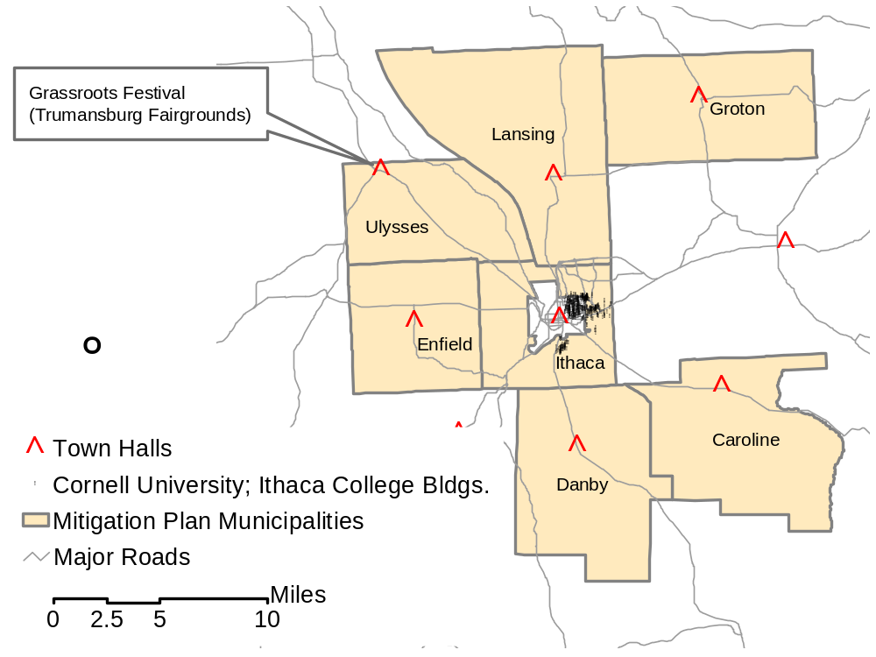
Source: Tompkins County GIS data

Additional Data and Next Steps

The computation of damages and losses due to civil unrest is not feasible at this time due to lack of historic cost data, the relative infrequency of such events, and the variable nature of such events. Tompkins County has never been the site of major protests or rioting resulting in significant losses or damages to property and, as such, no data are present to model future events. However, Tompkins County and the municipalities have been proactive in creating ordinances, including a permit program, related to protests and have worked with Cornell University and Ithaca College officials to develop policies geared toward curtailing unruly behavior associated with college parties and sporting events. These mitigation efforts should help to prevent or reduce future impacts associated with civil unrest.

Loss estimation cannot be calculated for the civil unrest hazard because currently no historic loss data exists for the impacts of civil unrest on the multi-jurisdictional study area or the cost of increased security for the types of events that could instigate civil unrest. The next step to assess the losses would be to collect this data to project the costs that could be associated with future episodes of civil unrest.

A methodology to employ, once the structural and content replacement values for the areas identified as potential structures at risk for a civil unrest event are determined, would be to identify the areas at risk for this hazard. The towns could then estimate the percent damage that might occur and multiply the value of the inventory at risk by the percentage to estimate potential losses. This methodology is based on FEMA’s How To Series (FEMA 386-2), Understanding Your Risks, Identifying and Estimating Losses (FEMA 2001) and FEMA’s Using HAZUS-MH for Risk Assessment (FEMA 433) (FEMA 2004). This does not, however, identify the cost of lives that could be lost, the cost of decreased productivity or the impact to emergency response personnel or facilities. Event preparation and response costs may be available based on past events in other locations. Also, data regarding preparation, damage, and response costs for annual civil unrest events like major annual parties at the universities can be compiled and studied.

Overall Vulnerability Assessment

Civil unrest is not a major concern to the study area, but the presence of two college campuses near and in the study area presents an opportunity for civil unrest that also can impact plan municipalities. Political and social activism is high at the universities. Other risk factors include the annual Grassroots Festival, which provides a forum for civil unrest-related activities. Public ordinances to address civil unrest are currently in place, including procedures and permit requirements for organized protests and college parties. Infrastructure, building stock, and critical facilities are not likely to be affected by episodes of civil unrest, although facilities could be damaged in the event of a riot (highly unlikely) and minor property damage and vandalism has occurred in association with university protests and parties.

4.4.4 Additional Data Needs and Next Steps
Several areas were identified in the preceding sections for which additional data would be useful to model risk, vulnerability, and losses. These data and their potential sources and usefulness relative to specific hazards are presented in Table 4-4-22. Efforts to collect this data should be balanced with the need to initiate mitigation strategies that address high priority hazards. As well, data collection efforts should be prioritized to maximize the fulfillment of data needs.
Table 4-4-22. Data Needs to Support Future Refinement of Loss and Exposure Estimates
Data Needed | Potential Source | Potential Usefulness | Hazard Evaluations Supported
Spatial and attribute information for overhead and underground utilities (age, type of equipment, past problems, proximity to facilities, etc.) | Private and public utilities, County and Town Public Works Departments | Evaluation of areas prone to power outages | Flood; Severe Winter Storm (Including Ice Storm); Utility Failure; Severe Storm (Including Hurricane); Major Transportation Accident (Including Hazmat Release [In Transit]); Terrorism; Fire (Urban and Wild)
Cost and loss information pertaining to utility failure and blackouts | Private and public utilities, County and Town Public Works Departments | Modeling and estimation of future losses | Flood; Severe Winter Storm (Including Ice Storm); Utility Failure; Severe Storm (Including Hurricane)
Outage, replacement, and maintenance records for utilities (e.g., power lines, sewers, WTPs, etc.) infrastructure | Private and public utilities, County and Town Public Works Departments; County, State, and Federal Transportation Departments | Modeling and prediction of future utility failure events | Flood; Severe Winter Storm (Including Ice Storm); Utility Failure; Severe Storm (Including Hurricane); Major Transportation Accident (Including Hazmat Release [In Transit])
Data on the location, severity (property losses, injuries, fatalities, etc.), frequency, and causes of traffic accidents | Transportation Departments, Public Safety Agencies (Police, Fire and Rescue, other); Insurance Companies | Modeling and prediction of future accident hazard areas, events, and losses | Severe Winter Storm (Including Ice Storm); Major Transportation Accident (Including Hazmat Release [In Transit]); Water Supply Contamination
Replacement value, expenditure, spatial, and maintenance records for transportation infrastructure (roads, bridges, rail lines, airports, etc.) and other critical inventory | Transportation Departments, County and Town Clerk and Treasurers, Public Works Departments | Modeling and prediction of future accident hazard areas, events, and losses | Severe Winter Storm (Including Ice Storm); Major Transportation Accident (Including Hazmat Release [In Transit]); Water Supply Contamination
Vegetation cover and attribute information for critical structures (locations, proximity to roads, homes, facilities, age, maintenance, etc.) | County, State, and Federal Environmental and Planning Departments; Cornell Geography and Biology Departments; Land Use Departments | Modeling of potential power outages, problems, and disruptions due to falling trees and branches and better estimates of wind impacts | Flood; Severe Winter Storm (Including Ice Storm); Utility Failure; Severe Storm (Including Hurricane); Major Transportation Accident (Including Hazmat Release [In Transit]); Terrorism; Fire (Urban and Wild)
Information regarding disease outbreaks and prevention measures (e.g., type and severity of disease, number of people affected, locations, international travel, response and controls, immunizations, cancer registries, losses, etc.) | County, State, and Federal Public Health Departments (e.g., Tompkins County Public Health Department, NYSDH, CDC, etc.) | Prediction of events and losses associated with future outbreaks and response | Epidemic (Human); Epidemic (Agricultural); Water Supply Contamination; Terrorism
Attribute and spatial information regarding critical facilities and vulnerable infrastructure (e.g., construction materials, security, number of people typically present, “importance” of resource, structural considerations, proximity to residential and economic centers, etc.) | County Assessor, Recorder, Treasurer, HAZUS-MH, land use planning agencies, etc. | Assessment of vulnerability to terrorism and other hazards not currently evaluated by HAZUS-MH | Terrorism; Civil Unrest; Fire (Urban and Wild); Water Supply Contamination; Utility Failure
Information regarding fires, emergency response, and Hazmat responses (e.g., type and severity of event, number of people and structures, affected, locations, response and controls, causes, losses, etc.) | County and Town Fire Marshall; Hazmat Teams; County, State, and Federal Environmental Departments | Assessment of vulnerability to fire and chemical release | Fire (Urban and Wild); Major Transportation Accident (Including Hazmat Release [In Transit]); Water Supply Contamination
Mapping and refined data on hazard areas and hazard factors (topography, landslide potential, aquifer characteristics, etc.) | County and Town Officials, State and Federal Agencies | Assessment of areas for mitigation and of areas of high exposure | Flood, Severe Winter Storm (including Ice Storm); Severe Storm (including Hurricane) Fire (Urban and Wild); Epidemic (Human) Epidemic (Agricultural)

