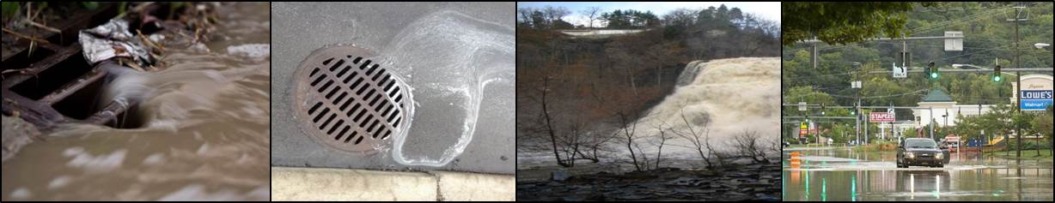

Stormwater Management

Code Review and Recommendations
Contents
Introduction and Summary of Findings 2
Code Review 4
Chapter 114 Natural Areas - http://ecode360.com/8386979#8386979 4
Chapter 176 Environmental Quality Review - http://ecode360.com/8388699#8388699 5
Chapter 186 Flooding Damage Prevention - http://ecode360.com/8389425 5
Chapter 276 Site Plan Review - http://ecode360.com/8392621 6
Chapter 282 Storm Water Control - http://ecode360.com/8392778 6
Chapter 283 Stormwater Utility 7
Chapter 325 Zoning - http://ecode360.com/8393835#8393835 7
The Southwest Guidelines 8
City Trees Master Plan 8

City Of Ithaca
Conservation Advisory Council
March 2016

Introduction and Summary of Findings
The Conservation Advisory Council is a State-mandated board formed to advise the City’s Common Council and Planning Board on matters of conservation and environmental concern. In this capacity the CAC has carefully reviewed the Stormwater Utility legislation and City regulations that are relevant to stormwater management.
The CAC is working to fulfill the City Stormwater Management Findings, Purpose, and Objectives (City Code ch 282) and to calibrate City codes with the new Stormwaetr Utility code (ch 283). This Code review recommends updates and adjustments to City code to help meet the goals and recommendations for stormwater management and improved water quality as described in Plan Ithaca (pp. 124-125).
Stormwater management measures seek to reduce the regular and significant impacts caused by erosion, sedimentation, flooding, and contamination. Stormwater runoff rates and flood volumes can be extreme in the urban context and are leading to ecological degradation of our gorges, creeks, and the lake. The CAC has observed and researched these issues with conclusion that impacts are significant. Reducing these effects are a priority for the conservation of natural areas and the integrity of urban infrastructure in Ithaca.
The CAC has observed projects built according to the minimum code requirements. Repeatedly project plans are explicit in outlining the least amount due for designs and the planning process. The rights for developed land use have created a pattern of little responsibility and poor standards in design which result in environmental and economic impacts.
The introduction of the Storm Water Utility legislation has inspired awareness in the community and enabled new dialog between agencies. This is giving potential for large scale projects such as flood modeling, inter-municipal cooperation, and FEMA attention to local Flood Maps. The Utility User Fee itself has generated a new funding stream and is tied to the individual parcels and projects directed according to code requirements. However, the User Fee does not improve deficiencies in planning and design nor has it provided incentive for additional Best Management Practices. With approval of the law certain requirements remain outdated and may be in conflict with the User Fee intentions. Further, new projects will continue to be built in the City according to designs with minimum standards and significant consequences on natural resources until a zoning and code revision occurs.
An important component of Stormwater Management for development is provided through zoning and code requirements. These mechanisms work through site plan review to maintain standards. The CAC has observed examples where changes to the City code would help discourage development that impairs ecosystems and encourage sustainable development patterns, including effective stormwater design. A code review and subsequent code changes represents the initial steps toward creating a clear and integrated approach to managing Ithaca’s natural resources with the growth of an urban core.

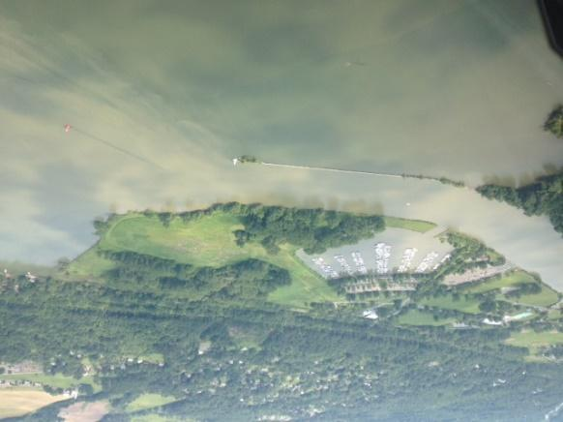
The CAC found the following codes are relevant to stormwater management:
Chapter 114 Natural Areas, Chapter 176 Environmental Quality Review, Chapter 186 Flooding Damage Prevention, Chapter 276 Site Plan Review, Chapter 282 Storm Water Control, Chapter 283 Stormwater Utility, Error! Reference source not found., Chapter 325 Zoning, The Southwest Guidelines, City Trees Master Plan.

Looking down on the map of Ithaca it’s easy to see how the natural elements bring such important quality of life and history to Ithaca. These also subject the City to extreme circumstances.
The following recommendations are intended to streamline and emphasize the City Code as a mechanism for planning and nurturing where the urban and natural areas meet or combine in the City.
The CAC code review and recommendations provide measures to reach the following objectives:
- Reduce impacts of Stormwater Flow and Flooding through the reduction of runoff rates, volume, pollutants, and soil erosion. (Plan Ithaca)
- Clarify the City Natural Areas and provide mechanisms to preserve those important natural resources which include primary waterways and steep slopes.
- Orientate changes in code to enhance and clarify requirements for parcels near and abutting central streams, creeks, gorges, and Natural Areas.
- Guide future development with City conservation planning.
- Any changes to code are intended to be calibrated with the Stormwater User Fee legislation and work with the existing stormwater management operations.
These objectives are, without dispute, priorities for the City of Ithaca and the region because they seek to mitigate stormwater impacts. The Conservation Advisory Council supports a unified response to deal with stormwater impacts drawing on understanding from ecological management practices and marrying it with urban planning. This document looks to harmonize and strengthen existing code. There may be additional legislative measures that are required to fully comply with Plan Ithaca and the spirit of other stormwater initiatives such as the Stormwater Utility User Fee.

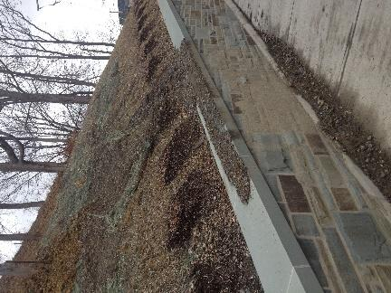
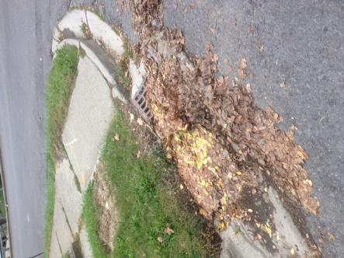

Code Review
In this section, we review chapters of the City of Ithaca’s code and other key City documents that reference stormwater issues. Each section has a link to the online e-code chapter as a companion for content. For each chapter we describe some deficiencies or opportunities in the code to move toward more effective management of stormwater in the City.

Chapter 114 Natural Areas - http://ecode360.com/8386979#8386979
- In general, the City’s Natural Areas are adjoining dense and enriched neighborhoods, they are ecologically important, and some are in a flood zone. However the Natural Areas are not clearly defined in the code language. The actual Natural Areas are defined under a patchwork of different entity/ownership designations and this information is not centralized or coherently available. The City needs to clearly define all gorges, creeks and streams where they flow in and through the city as a Natural Area.

- There are no defined Critical Environmental Areas in the City while several areas would qualify for the designation. CEAs initiate different site plan review requirements for development.

- More than half of the steep slopes in the City are in the Natural Areas. Improved and clarified designation of the Natural Areas will result in management for much of the steep slope inventory.

- These recommendations are substantiated in Ch 320 Watershed with definition of Six Mile Creek as a unique natural area which is vital to the City with adjacent buffer areas. In addition, the FEMA Flood Insurance Rate Map (FIRM) describes central waterways in Ithaca which are currently not considered a Natural Area or protected by code requirements.

Chapter 176 Environmental Quality Review - http://ecode360.com/8388699#8388699
  - A Project is listed as a Type I action when it meets certain criteria such as within 100' and/or using more than 5 acres. These minimum requirements are important for requiring an Environmental Impact Statement (EIS) and Stormwater Pollution Prevention Plan (SWPPP). The measurements can be adjusted to recognize the properties and projects relevant to nearby creeks, streams, gorges, and slopes. As a Type I action those projects will therefore require an EIS and in some cases a SWPPP to provide more storm water management.

  - The CAC recommends adjustment of Type I mechanisms; all 100’ buffers are extended to 200’ and the 5 acre minimum lot size is reduced to 1 acre. (Note the Parcel Count Map included in this document.)

  - Minimum Vehicle Trips can be reduced from 500 to 250 vehicle trips counted in 8 hours. This adjustment helps manage the provisions for vehicles such as parking surface area.

Chapter 186 Flooding Damage Prevention - http://ecode360.com/8389425
  - Those who occupy the Flood Zone and/or are near a waterway assume responsibility for the occupancy operating in that location and with high risk flood hazard conditions. The CAC feels this section can endorse more effective standards as minimum requirements and adjust fees for development inside a Flood Zone.

  - The basis for interpretation needs to uphold both the responsibility and conditions of sites in the Flood Zone. The provisions interpreted are held to “Minimum Requirements”. The objectives are better supported with a change of wording to explain the interpretation of provisions according to “Exceptional Standards” and/or designs suggested in Better Site Design (Ch 282-47).

  - Some sections may need to be adapted to maintain the objective and also support the User Fee which represents an increase in required public funds. Increasing the standards and fees in the flood zone will support meeting the objectives to stabilize and reduce tax burdens (as noted in ch 282 sec B. and sec F.

  - The penalties are low and are not incentive to provide minimum requirements nor do these reflect the importance of flood damage prevention. In some cases the penalty fees are less than the Stormwater User Fee creating a contrary incentive.

  - NYSDEC additional language on Flooding may be considered as supportive ordinances for this section. Some additional language will require storm water management in Flood Zones and entitle the City to insurance rebates.

NYSDEC Optional Additional Language Model Local Law for Flood Damage Prevention http://www.state.nj.us/drbc/library/documents/Flood_Website/FRES/NYSDEC-OptionalLanguage.pdf

The Model Local Law for Flood Damage Prevention contains language that complies with the floodplain management requirements of the National Flood Insurance Program (NFIP). Setting higher standards protects against these risks. Many of the following techniques result in lower flood insurance premiums either directly or through the Community Rating System (CRS). Flood insurance policies within communities with over 500 CRS points receive a five percent discount on each individual insurance premium. Flood insurance policies within flood hazard areas in CRS communities receive an additional five percent discount for each additional 500 points. Contact NYS DEC or visit the CRS Resource Center at http://training.fema.gov/emiweb/crs/ for more information about the Community Rating System.
Examples: Compensatory Storage. Cumulative Substantial Improvement. Critical Facilities.

Chapter 276 Site Plan Review - http://ecode360.com/8392621
  - Consider options for sloped area management and controls for reduced erosion.

  - Increase the allowed and required percentage-size of interior grounds/green areas in parking lots.
  - Consider and review the STAC proposed planting guidelines for parking areas outlined in City Trees Master Plan.

  - Require retention and compensatory storage for parking areas within flood and sloped zones rather than “encourage” pervious surfaces.

Chapter 282 Storm Water Control - http://ecode360.com/8392778
  - Stormwater plans are required according to minimum parcel size and grade of slope. The minimum sizes can be adjusted to help increase the project review requirements at parcels and properties in proximity waterways or where the impermeable surfaces for parking will compound sheeting runoff rates.

  - Slope grade of 5% is used with minimum areas as a threshold between Full and Basic SWPPP. The CAC recommends a tiered approach to slope regulation is created using parcel areas smaller than ¼ acre and slopes grades greater than 5%.

  - The penalties are low and are not incentive to provide the minimum requirements, nor do these reflect the importance of Stormwater Controls. In some cases the penalty fee is less than the Stormwater User Fee creating a contrary incentive.

Chapter 283 Stormwater Utility
- The Stormwater User Fee legislation has renewed and revitalized the City commitment to our environment in the Finger Lakes region. The User Fee will provide a dedicated source of funding for the Department of Public Works to use on storm water management and infrastructure in the City.

- After implementation in 2015 it will be important that the User Fee can furnish the Deot of Public Works budget with funding to be focused on operations which effectively improve strained stormwater systems and reduce harmful impacts. Adequate and attentive operations are vital for the City’s resilience under storm conditions. Visible and innovative examples are also needed for community members and property owners to understand positive design impacts.

- The CAC has identified two potential additions and/or changes to the Stormwater User Fee to develop incentive for Best Management Practices:

- The City Flood zone and Floodways are defined according to the FEMA maps. These areas require good stormwater management. The User Fee rates can be increased at properties in a Flood zone and/or with steep slopes to provide clear incentive for best practices at High-Risk locations. They can also be eligible to earn a greater Fee Credit to use against good stormwater design construction costs. NYSDEC additional language on Flooding may be used as supportive ordinances for this section and entitle the City to its own credit through insurance (FIRM) rebates.

- The User Fee Credit is not available for Single Family and Duplex properties. This excludes the segment of Ithaca’s community who owns their home and thinks a lot about stormwater impacts vs remediation. There is no recognition for the public community who cares. The CAC recommends consideration of a full Fee Credit for homeowners who can demonstrate effective stormwater management practices on their parcel.

Chapter 325 Zoning - http://ecode360.com/8393835#8393835
  - Parking Requirements are in Residential zones including R3 where multiple units exist. Parking areas developed in zones such as SW and R3 have been detriment to the City canopy and increased water runoff volumes.

  - Parking requirements create parking areas which are also subject to the Utility User Fee due to the impervious surfaces. The fees have an intention for incentive to reduce surface areas while zoning first requires those areas to be built. The CAC is concerned about a legal conflict with a fee imposed on a required provision. The most environmentally responsible action to take is remove all parking requirements. This will meet the intentions of the new stormwater legislation.
  - Maximum yard area for parking can be adjusted and reduced to maintain more green areas on parcels. This can be an effective mechanism at parcels near and abutting the gorges and waterways.

  - Surface Materials required for parking areas includes hard concrete and other materials which create and compound stormwater runoff.

  - The structure set back from streams and inlets is 20 feet. Waterfront Zone properties are exempt and a recent proposal extended the exemption to other properties. This mechanism provides an important natural buffer to water ways and it is already missing in places.

  - Zoning requires project designs to calculate for a Two Year storm event. The CAC recommends designs made with a resilience for 5, 10, and/or 100 year storm events.

The Southwest Guidelines
  - The Southwest area guidelines and requirements are not suited for effective stormwater management or a healthy urban environment. This is exhibited in the existing development of the SW district which has created acres of pavement, destroyed the tree canopy inventory, and made structures dangerously close in proximity to important ecological tools for stormwater management.

  - A structure can be built as near as 20 feet from an inlet or creek. The CAC advises this buffer may be too small at some locations and is non-existent at others.

  - Minimum store sizes are very large. On a parcel, the required store size can be adjusted to create multiple structures, pedestrian pathways, green areas, and modified provisions for automobiles.

  - The SW district guidelines require hard concrete. Recent projects have ignored comments from the CAC advising construction of pervious surfaces and/or compensatory storage in the design. The requirement of concrete is also a conflict with the User Fee which is based on impervious surface areas.

City Trees Master Plan
The Shade Tree Advisory Committee (STAC) has published a thorough document about City Trees. Included are guidelines for tree planting in parking areas. The planting guidelines are important and effective for both the health of a tree and for stormwater volumes. The compensatory storage provided in structural soil built under a lot surface is essential for retention and filtration of storm water. The South West, West End, and Waterfront districts need this action to help remediate an impaired canopy and water system.

